Overview

Trigger:

Processing an Enrollment/De-Enrollment for the Dynamic Peak Pricing, Pre-Pay or CSDD program.

Business Process Procedure Overview
Background:

As part of the Smart Energy initiative Release 5, Users will have the ability to process enrollment requests for the Dynamic Peak Pricing (DPP) , Pre-Pay, and Customer Selects Due Date programs via Enrollment Center.

Participation in the CE Smart Energy programs is voluntary, and should a customer decide to no longer participate in program, they can simply de-enroll from program.

Input – Required Fields | Field Value/Comments
Enrollment in Dynamic Peak Pricing sub-programs | CE Customers are Eligible for enrollment in Critical Peak Pricing (CPP) or Peak Time Reward (PTR). The program Enrollment is initiated via the Enrollment Center. Enrollment Center can be accessed via Navigation Bar, in the Interaction Center WebUI in CRM 7.
Enrollment in Pre-Pay program | CE Customers are Eligible for enrollment in Pre-Pay program.  The program Enrollment is initiated via the Enrollment Center. Enrollment Center can be accessed via Navigation Bar, in the IC Web WebUI in CRM 7.
Enrollment in Customer Selects Due Date | CE Customers are Eligible for enrollment in Customer Select Due Date, provided certain eligibility requirements are met. The program Enrollment is initiated via the Enrollment Center. Enrollment Center can be accessed via Navigation Bar, in the IC Web WebUI in CRM 7.

Output - Results | Comments
CE Customer is either Enrolled or De-Enrolled from intended Programs | Customer will be either Enrolled or De-Enrolled

Table of Contents
1.0 Enrollment Center – Overview 4
2.0 Enrollment 6
2.1 Critical Peak Pricing 6
2.2 Pre-Pay Program Enrollment 22
2.3 Customer Selects Due Date - Enrollment 39
3.0 De-Enrollment 49
3.1 Critical Peak Pricing 49
3.2 Pre-Pay De-Enrollment 56
3.2 CSDD De-Enrollment 61

1.0 Enrollment Center – Overview

The Enrollment Center is a newly created Work Center, on the Navigation Bar in the CRM WebUI. The Enrollment Center is divided into 4 main components/views:
Enrollment Center components/views:
- Participating Program section will show the programs the customer is currently enrolled on. It also shows if there is a pending enrollment in process.
- Available Programs section will show the programs that the customer can enroll on. Action column will show Enroll when the account has passed program eligibility, or will show Ineligible if the account in not eligible to be enrolled.
- Eligibility messages section will show the messages as to why the program is ineligible. Clicking on the Ineligible link will display the ineligible reasons under the eligibility message view.
- Program History will show the accounts program history if the account has been enrolled previously on a program. Enrollment request date, enrollment date and de-enrollment dates will populate.
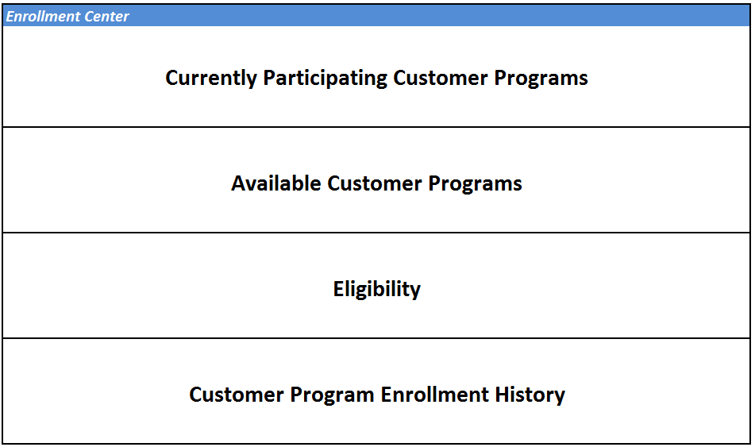

The Enrollment Center allows the user to Enroll/De-Enroll/Review the Smart Energy Customer programs offered by Consumers Energy. Currently four programs are available via Enrollment Center:
- Critical Peak Pricing (CPP)
- Peak Time Reward (PTR)
- Pre-Pay
- Customer Selects Due Date (CSDD)

For information about the program, the CSR can click on the program name, which will display the program description details. Red button will close the pop up. PrePay example below: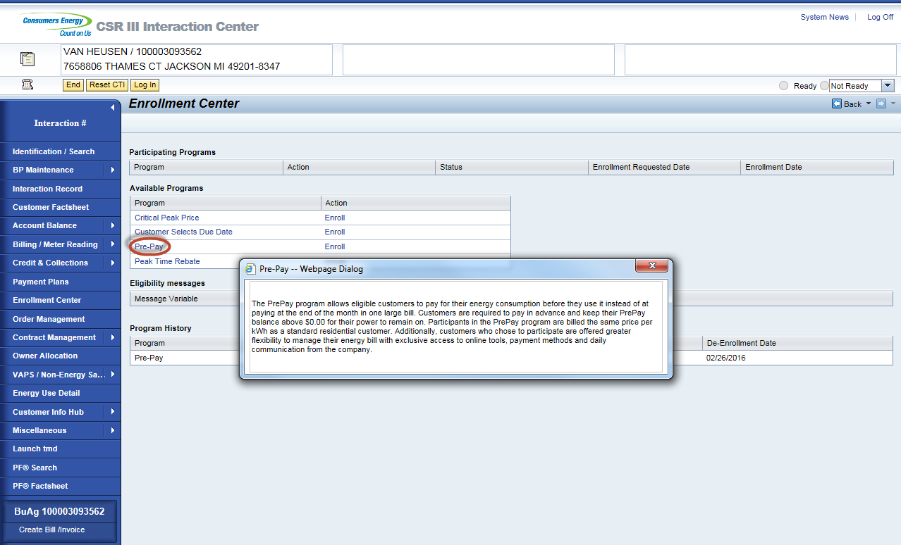
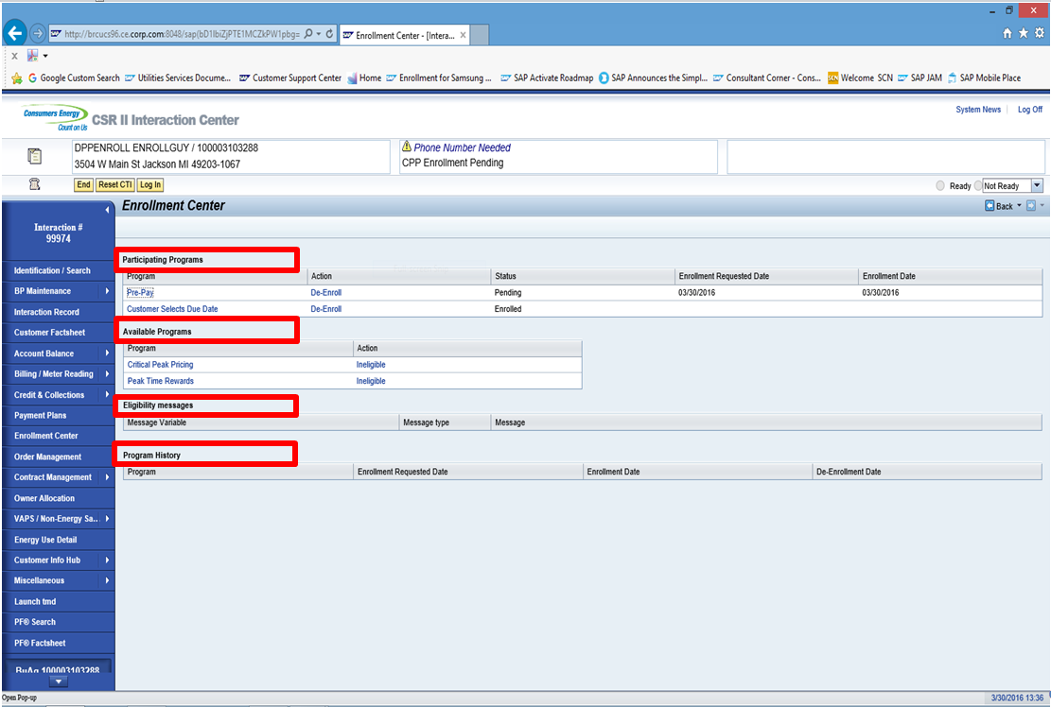

2.0 Enrollment

2.1 Critical Peak Pricing
DPP enrollments can be initiated by CE CSR and EV (Enrollment Vendor – Honeywell) this document only contains the steps required for CE CSR initiated enrollment. This process shows how to perform CPP Enrollment. The same process is also applicable to PTR (Peak Time Reward).

Business Agreement confirmed in CRM. This is done via an incoming call or by manually searching a Business Agreement.

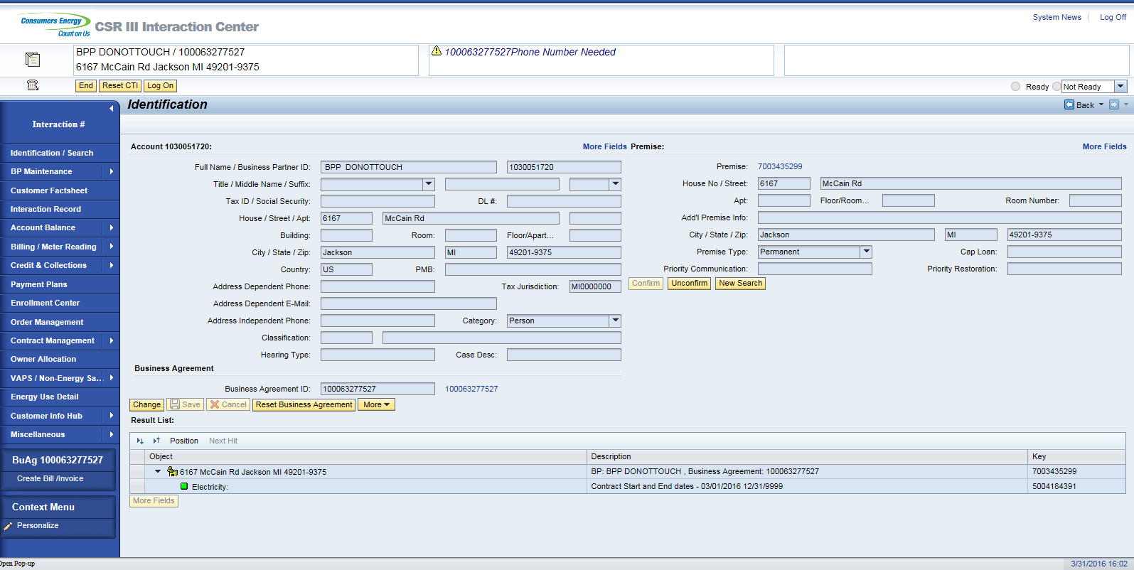

Once Business Agreement is confirmed, the CSR will click on the Enrollment Center from navigation bar.
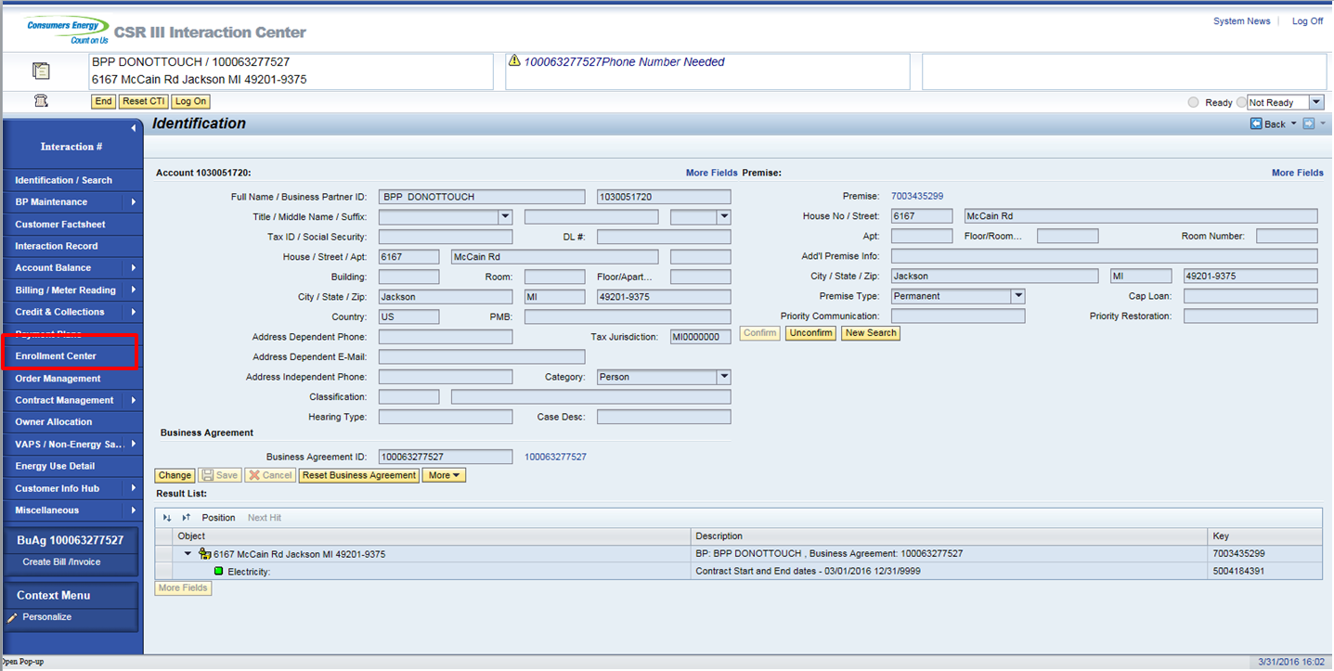

To enroll on CPP click ‘Enroll’ link next to Critical Peak Pricing under Available Programs Section.

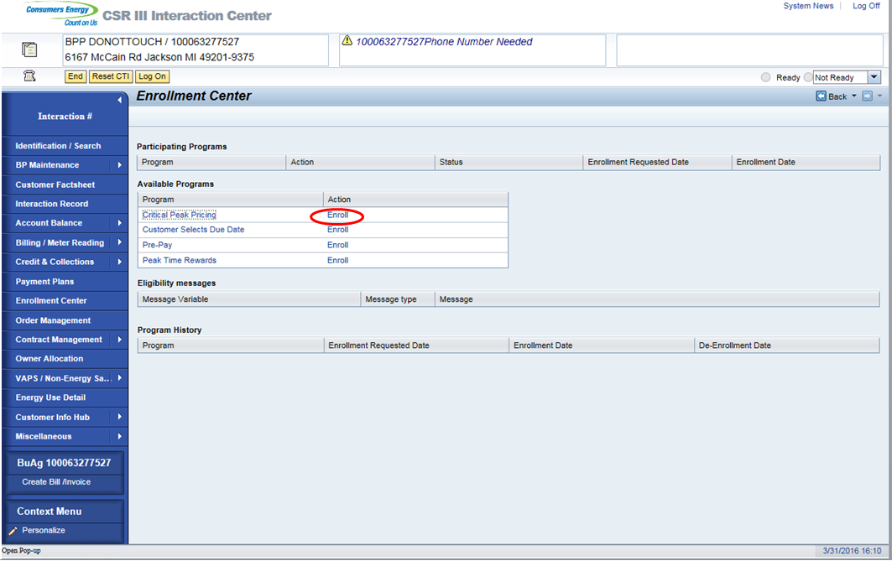

If DPP Program (CPP or PTR) shows ‘Ineligible’ link it could be due to the following reasons which will display under Eligibility messages when clicked.

Programs | Status | Text
Must have an active Electric Contract | Y | Active Electrical Residential contract exists. Gas contracts do not affect enrollment.
Over The Air Meter | Y | All devices are AMI enabled.
Pending theft/fraud/TOV investigation | N | Account has multiple active contract accounts.
Active contracts enrolled in the Payment Plans | N | Weather Protection Plan (WPP); Service Protection Plan (SPP); Budget Billing Plan (BBP); Energy Direct Plan (EDP)
APNEA monitor | N | Not eligible to enroll for DPP.
Life Support | N | Life support condition.
Medical condition | N | Medical condition exists.
Poor Communicator | N | Poor communicator flag on Meter.

When Enroll link is clicked; the customer contact details will be displayed. CSR will confirm the customer contact details. Incase customer contact needs to be added, click on Edit button.
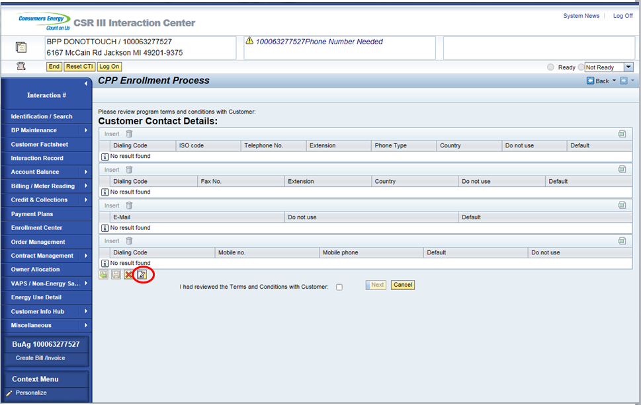

Customer’s contact details need to be maintained in this screen which will be used in Preference Center to maintain CPP Preference. Note: Customer’s email address is required for DPP Enrollment.

Click on Insert to add the entries.
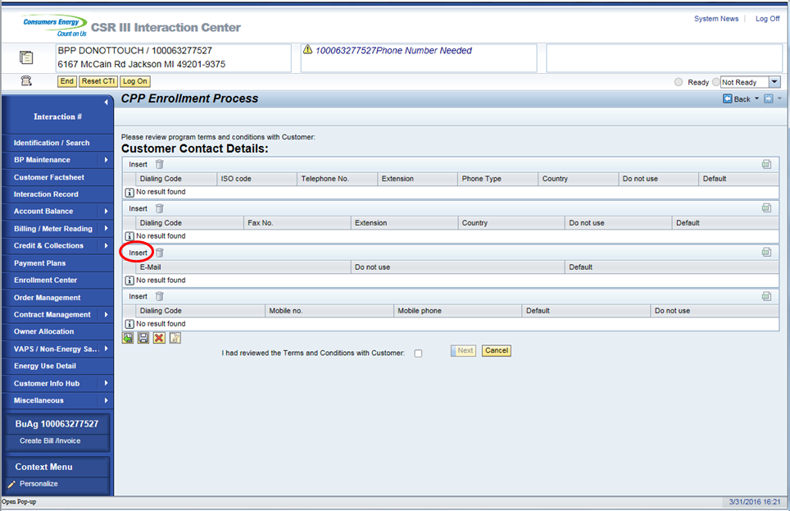

Maintain the email address as well as Mobile number if applicable.
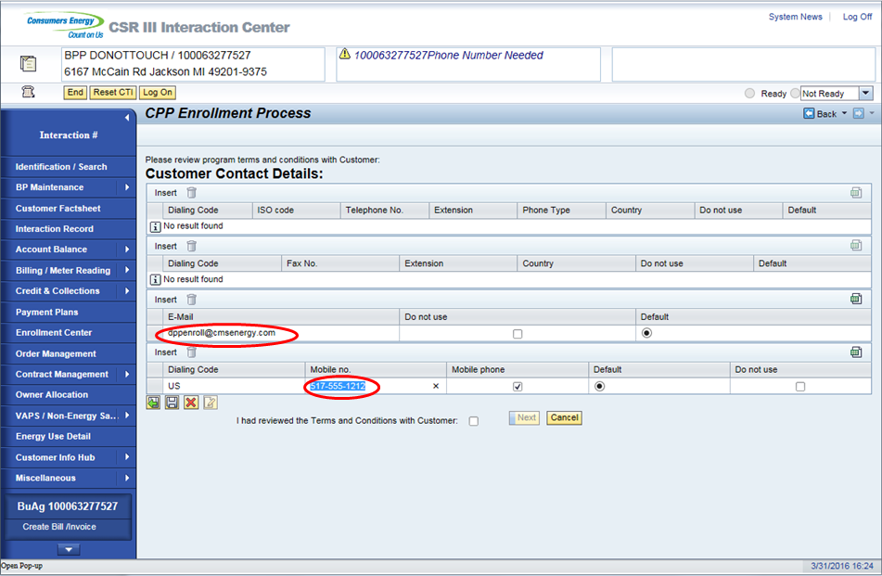

Click on Save button to save the customer contact details.
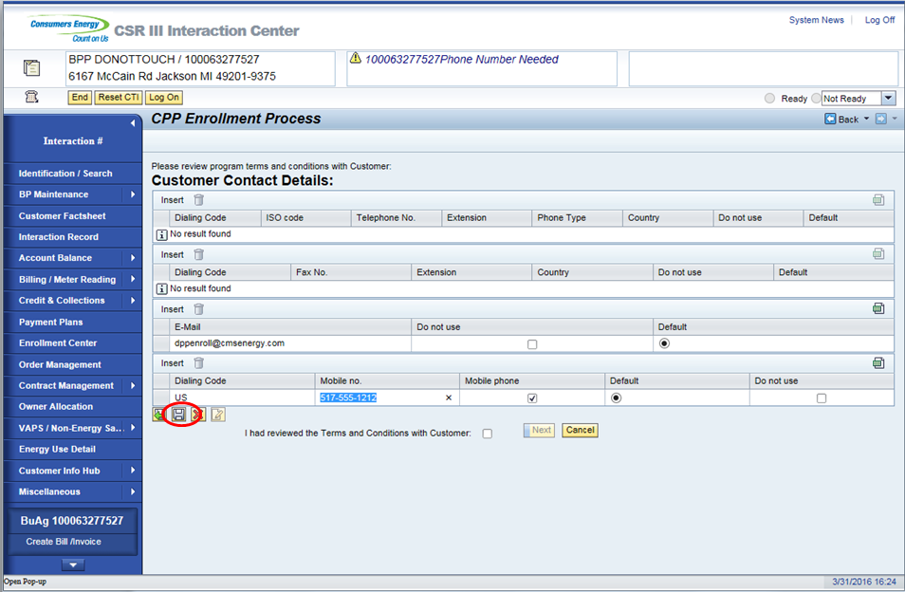

Please explain the Term and Condition with customer. Once the T&C has been reviewed with the customer, please select the check box next to text “I have reviewed the Term and Conditions with Customer”.
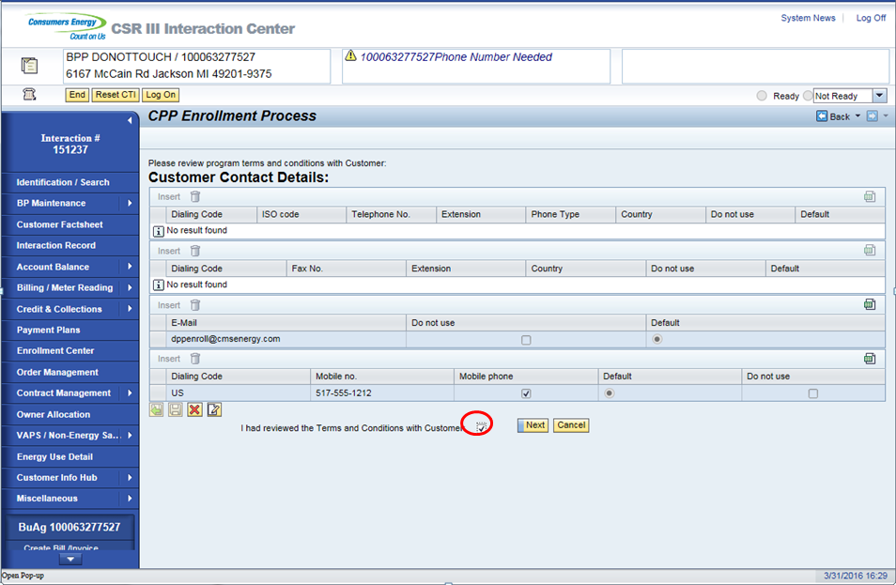

Once the check box is selected, Next button is available. Please click on Next button
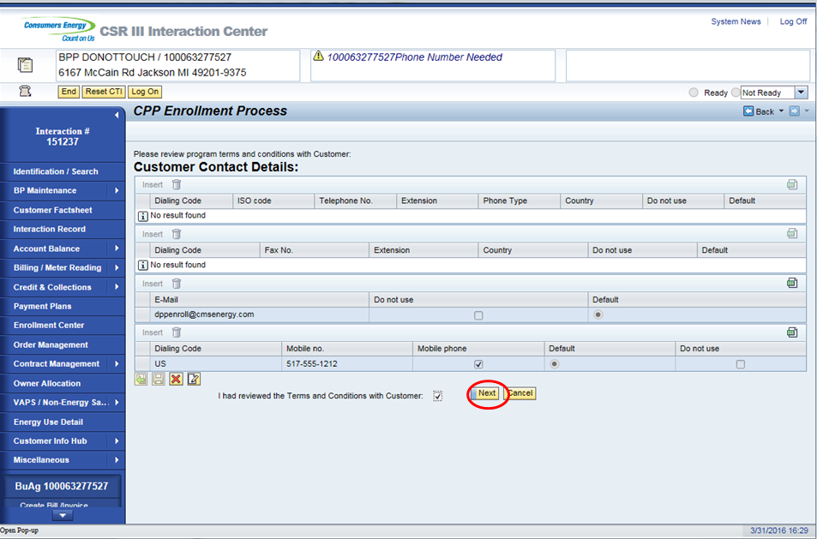

Once the Next button is clicked; customer will be taken to Preference Center screen where customer’s CPP Preference can be maintained. Select the preferred email address and/or mobile number that is capable of receiving the text. Once the Preference is selected; click on Save button to save the customer’s CPP Preference.
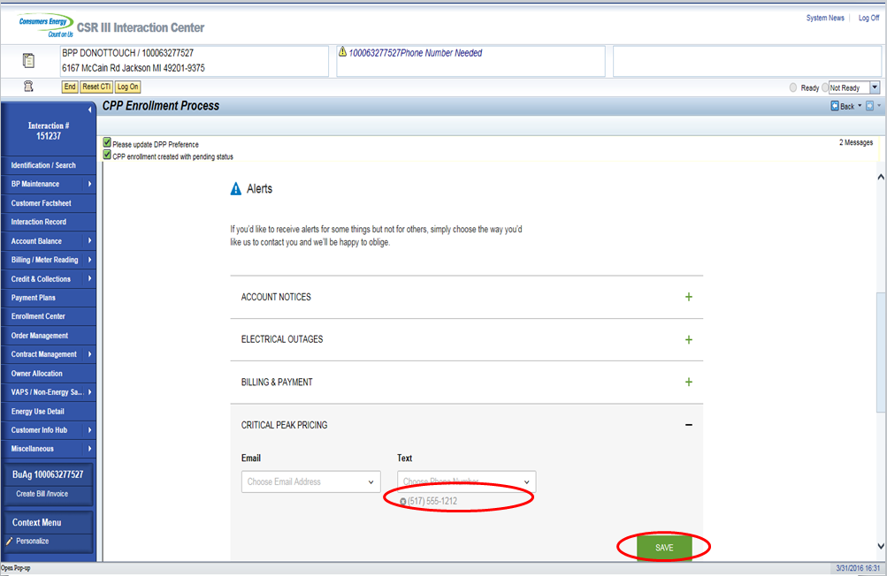

Once the preference is saved, click on Finish button.
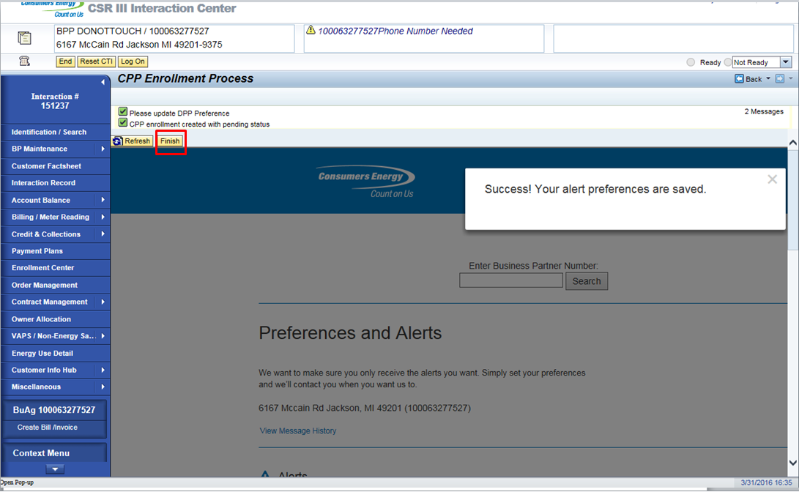

At this point, CPP Enrollment is completed and a message will displayed that “DPP Preference Captured. CPP Enrollment process complete.”
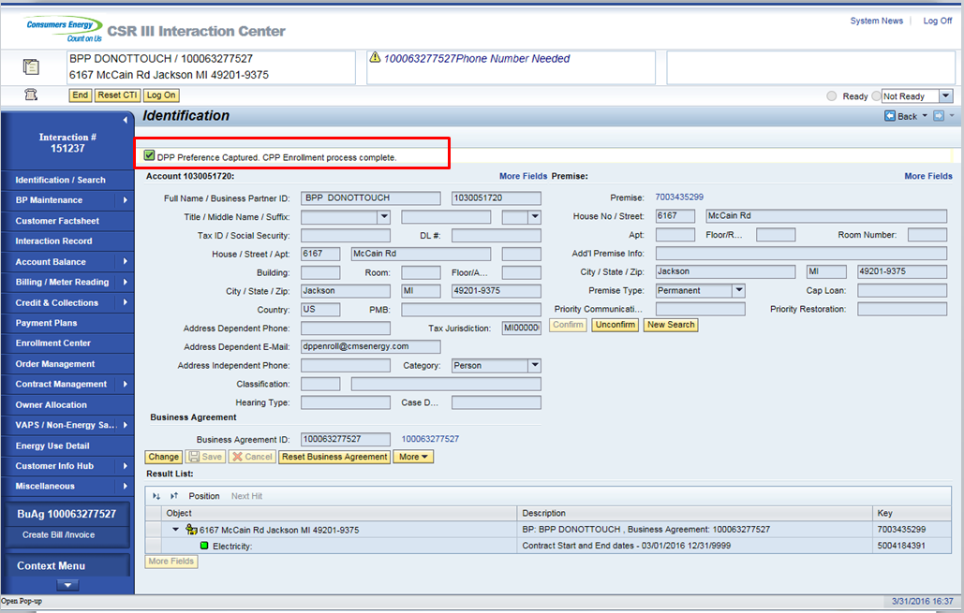

Navigating to Enrollment Center will display a Pending Enrollment in CPP.
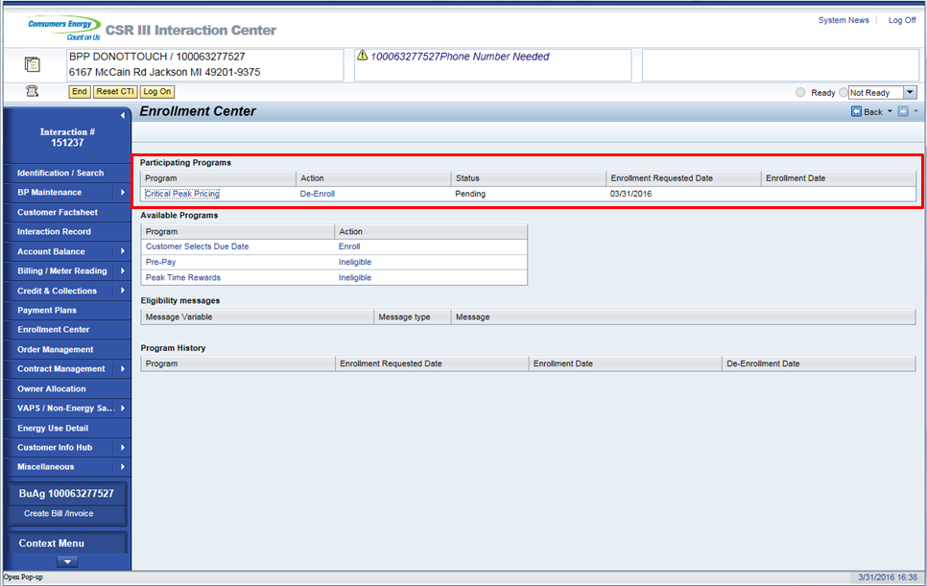

Interaction record is created. Selecting the Interaction Record work center from the navigation bar will display the interactions.

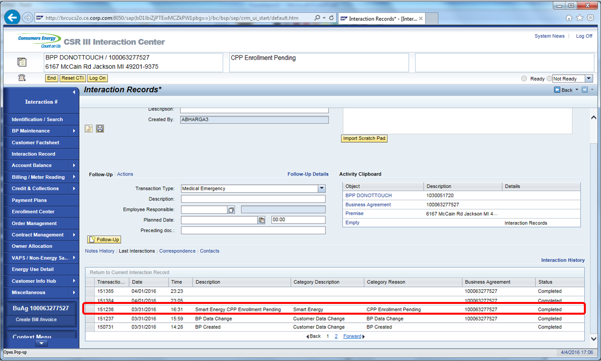

Confirming the account again in CRM; an Alert will display showing the Pending Enrollment.
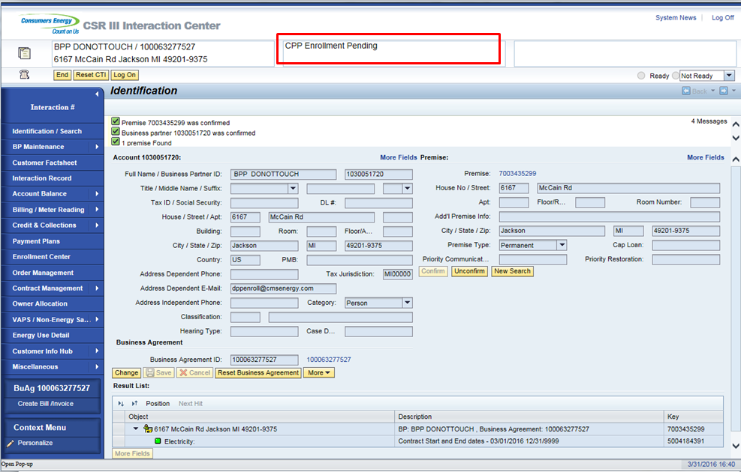

Note: Once the billing is completed and a rate change program executed in background. Customer will be Enrolled in CPP Program. Navigating to Enrollment Center will show that Customer is Enrolled in CPP.

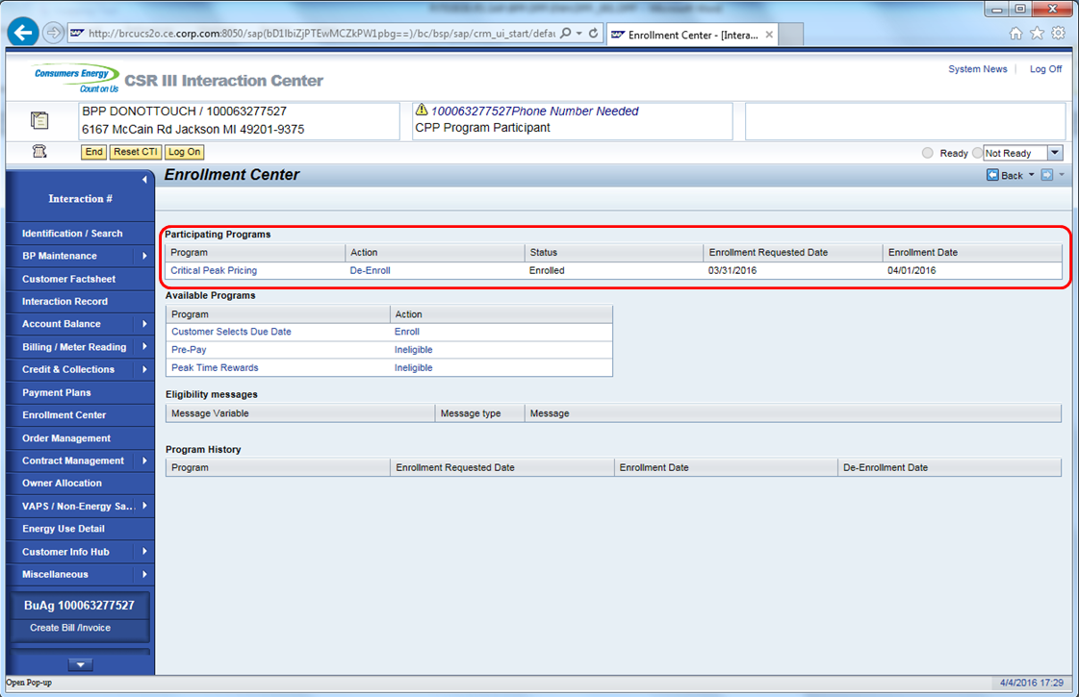

An Interaction Record will be created after the Enrollment is completed. Selecting the Interaction Record from the navigation bar will display the interactions.

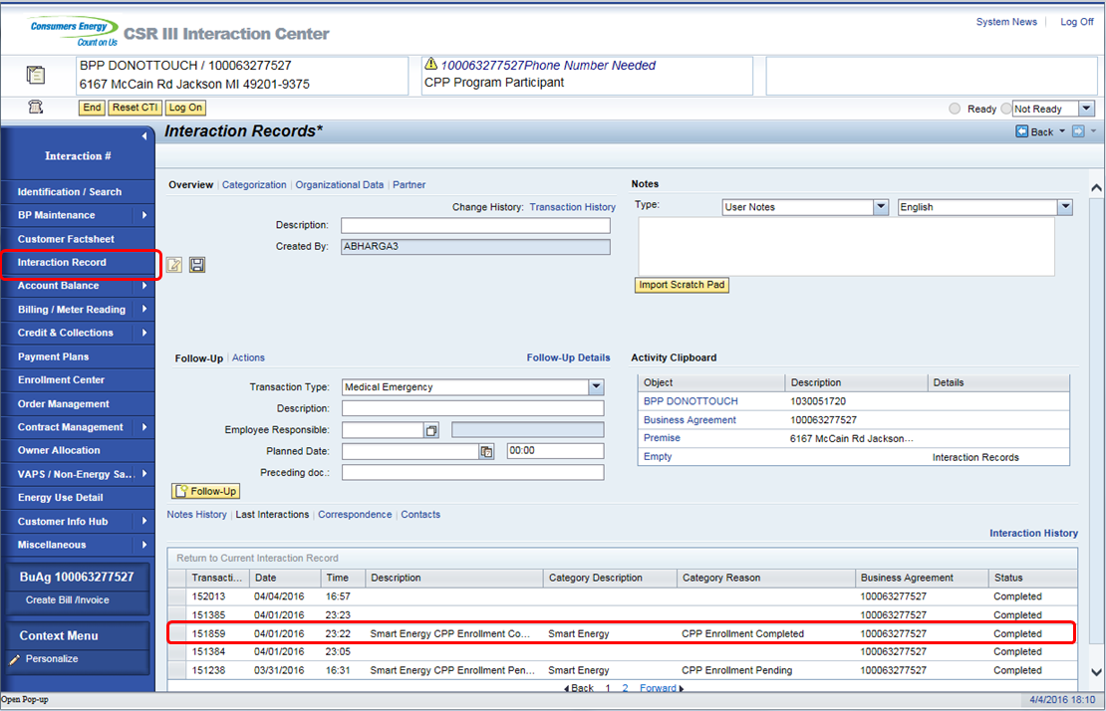

2.2 Pre-Pay Program Enrollment
This process shows how to perform a PrePay enrollment in CRM
Business Agreement confirmed in CRM. This is done via an incoming call or by manually searching a Business Agreement. 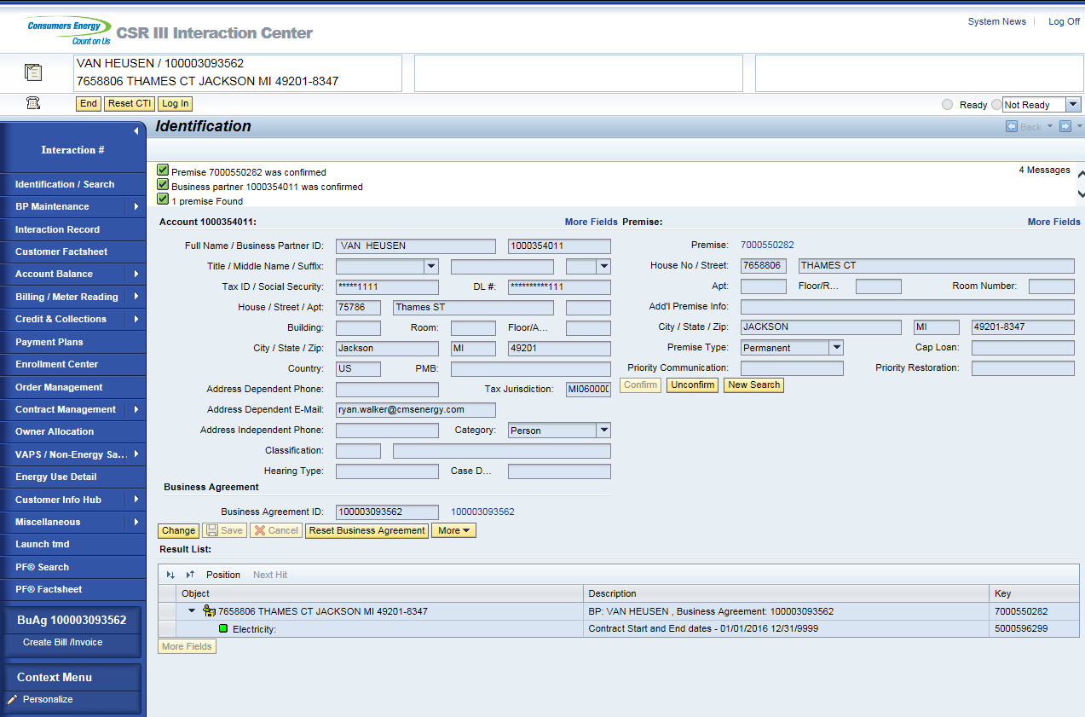
Once Business Agreement is confirmed, the CSR will click on the Enrollment Center from navigation bar. 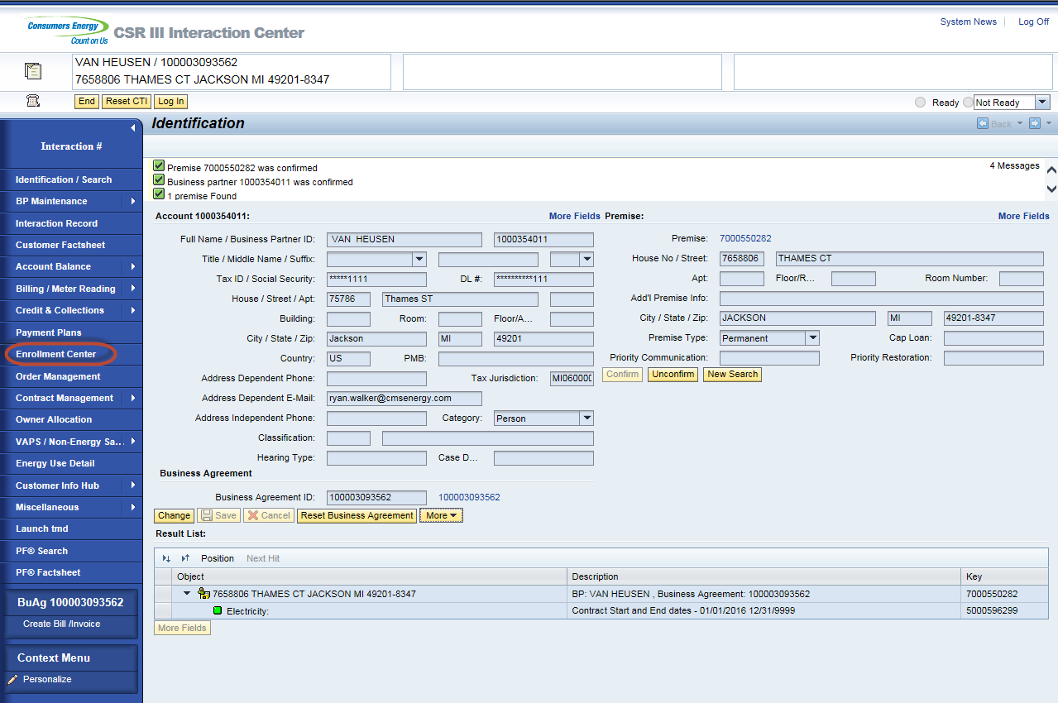
To enroll on Pre Pay click ‘Enroll’ link next to PrePay under Available Programs. 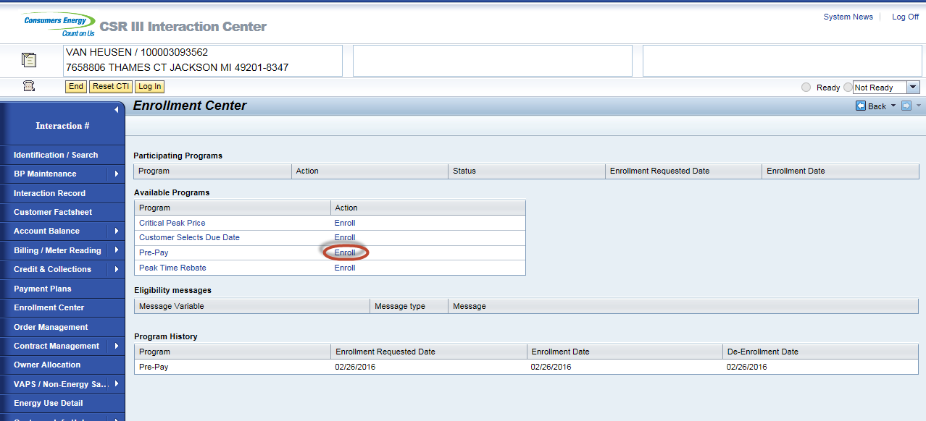
If PrePay shows ‘Ineligible’ link it could be due to the following reasons which will display under Eligibility messages when clicked.

Programs | Status | Text
Not an active Account | X | No active contract exists.
Multiple Account | X | Account has multiple active contract accounts.
Over The Air Meter | X | Not all devices are AMI enabled.
Life Support | X | Not eligible to enroll for PrePay.
Bill Consolidator | X | Not eligible to enroll for PrePay due to 'Name' (Checkfree, CitiBank, Cass, NISC, EDI - with paper invoice, EDI - no paper invoice, BillTrust).
Cust not on rate RS_1000 | X | Not eligible to enroll for PrePay. Rate 'XXX' 'Name'. (Examples Electric Choice, Dynamic Peak Pricing, Plug in Electric Vehicle, Time Of Day)
Cust not on rate A_250/A_260 | X | Not eligible to enroll for PrePay. Rate 'XXX' 'Name'. (Examples Gas Choice, Dynamic Peak Pricing, Time Of Day)
Facta Failure | X | Not eligible to enroll for PrePay until resolved.
PIR Contact | X | Not eligible to enroll for PrePay until resolved.
Collective Account | X | Not eligible to enroll for PrePay.
Green Generation | X | Not eligible to enroll for PrePay.
People Care | X | Not eligible to enroll for PrePay.
Net Metering | X | Not eligible to enroll for PrePay.
CARE 3.0 | X | Not eligible to enroll for PrePay.
Payment Plan | X | De-enroll customer from payment plan (BP, WPP, Or SPP)
Electric Past Due Balance | X | Past due balance must be below $200.00.
Combo Past Due Balance | X | Past due balance must be below $400.00.
Customer Selects Due Date | X | Need to change payment terms to CE21.
Cap Loan | X | Not eligible to enroll for PrePay.
Installment Plan | X | Need to de-enroll from installment plan to be eligible for PrePay.
Direct Pay | X | Customer will need to de-enroll from DP to be eligible for PrePay enrollment.
Recurring Card Payment | X | Customer will need to de-enroll from RCP to be eligible for PrePay enrollment.
iFactor | X | Billing and payment preferences need to be removed.

When enrolled link is clicked the Pre-Enrollment View Displays. CSR will read the information on the page to the customer. 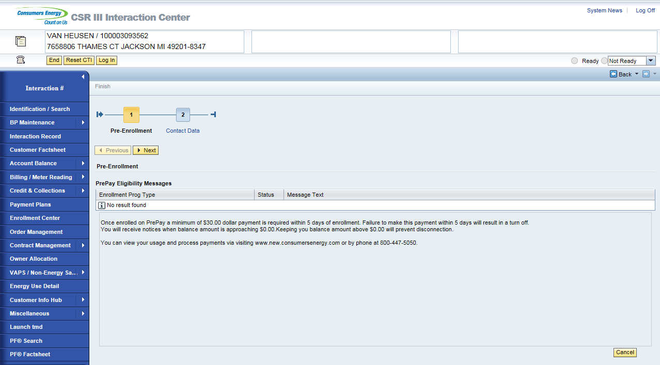
*Existing customer enrollment - customer with at least one bill, will display the following message on the Pre-Enrollment Screen:
“When enrolling in prepay, a new account number will be generated. Your previous account will be closed and a final bill will be issued which must be paid. If the balance is not paid, it will be transferred to your new account number, 20% of the amount the customer chooses to pay will be used toward the outstanding balance. 80% will then be applied to the prepay account for future use. All future payments are to be applied to the newly generated PrePay account. “

Warning messages will display under PrePay eligibility messages if the account is on any of the following. These messages do not prevent enrollment. This is information for the customer and CSR.

Program | Status | Text
Recurring Card Payment | Yellow Warning | Inform customer that final bill will be paid due to enrollment on RCP
Direct Pay | Yellow Warning | Inform customer that final bill will be paid due to enrollment on DP
Payment Plan | Yellow Warning | Inform customer that PrePay enrollment will auto de-enroll from (SPP, WPP, BPP)
Appliance Service Plan | Yellow Warning | Inform customer that their ASP plan will be canceled on enrollment.

If customer still wants their Appliance Service Plan, the CSR will need to complete the PrePay enrollment and enroll the Customer into a plan that is not tied to their utility bill. PrePay enrollment process will need to be completed so the CSR can enroll on the ASP plan using their new active Contract Account.

Once the information is provided to the customer, the CSR will click next button or Contact Data button to view the Contact Data view.

CSR will need to collect a Preferred and Critical communication method.

- Email address is required for the Preferred Communication. A enrollment email, general account balance, information and alerts will be sent to this email. This email can only be changed on the PayGo site once the enrollment is completed.

- Email, Phone or Text is required for the Critical Communication. Low balance alerts and disconnection notifications will be sent to the method that the customer has picked. Critical email address cannot be the same as the preferred. Critical method can only be changed on the PayGo site once the enrollment is completed.
Once the Preferred and Critical methods are entered, the CSR will hit Submit. 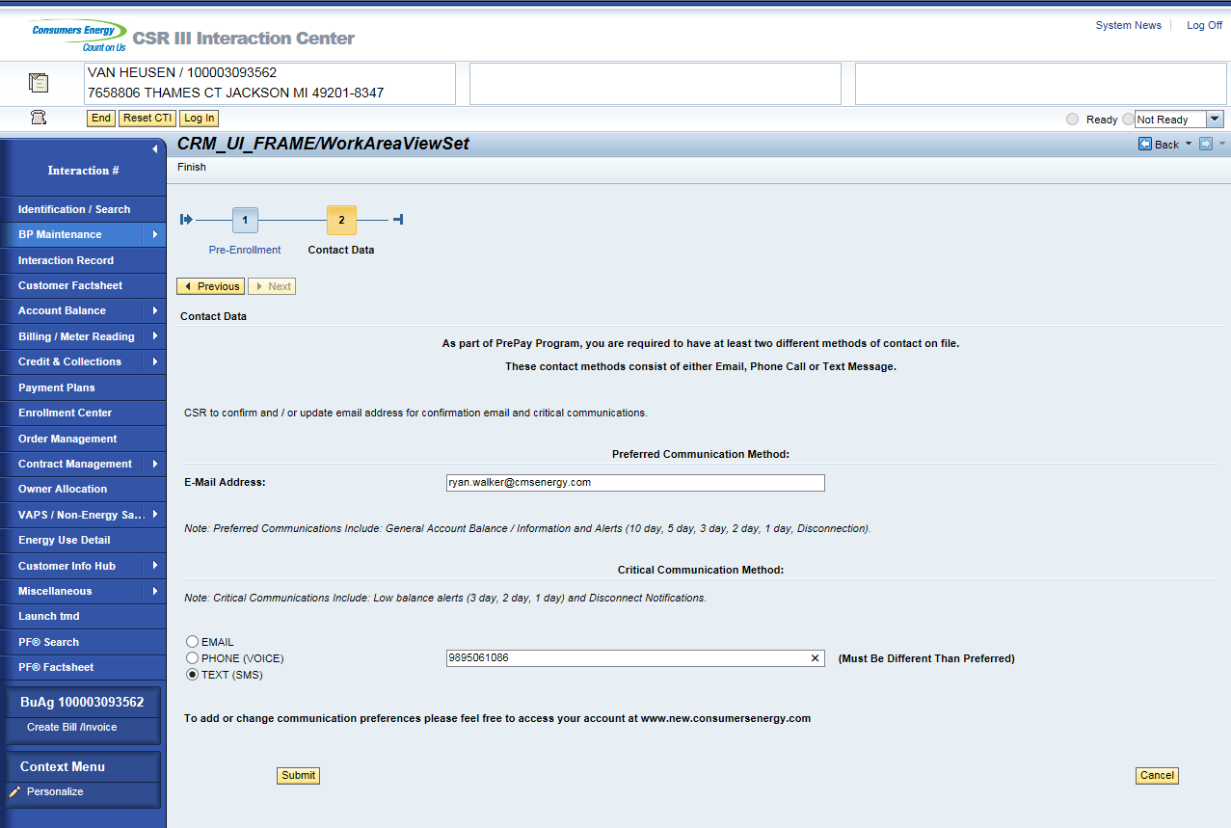
Summary Screen displays CSR will let the customer know that the enrollment is not completed until they receive there confirmation email. Contract Account number will display automatically when the enrollment has occurred for a new customer (Customer that has not been billed). Get CA button will display on the summary when it is an existing customer (Customer that has been billed). The CSR will click on the Get CA button to pull the Contract Account number. This button is needed due to timing needed for the workflow to process the new contract account in the back office. CSR’s will be able to click the Get CA button up to 3 times. If the third time fails to pull the contract account, the BP number will display.

New Customer:
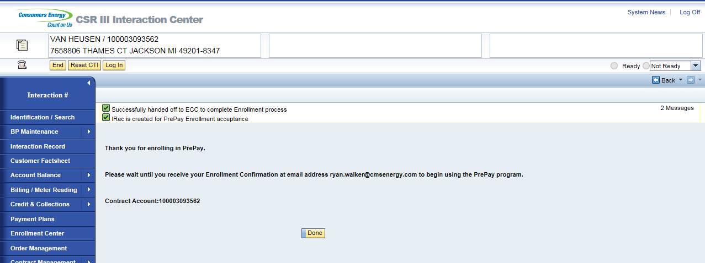
Existing Customer: Select Get CA button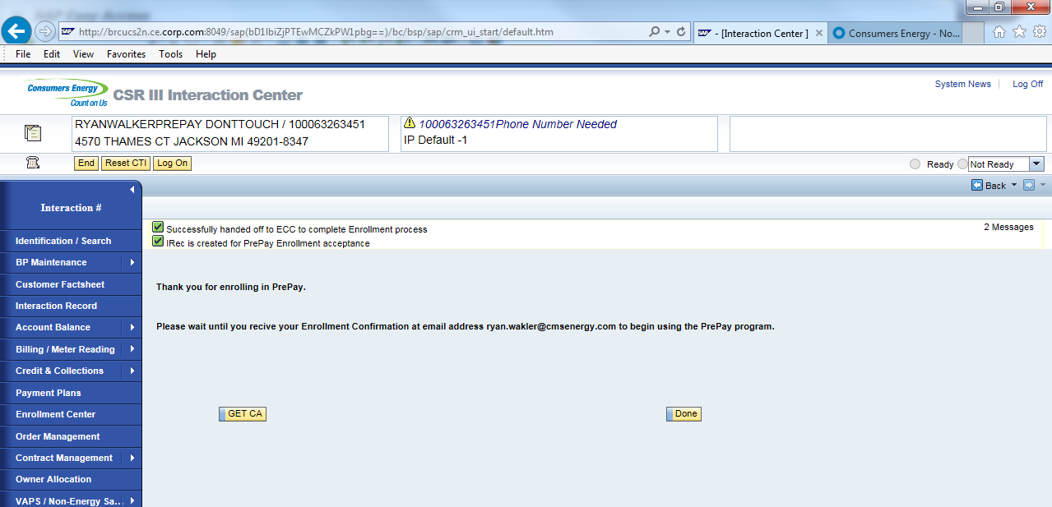
Account number displays.
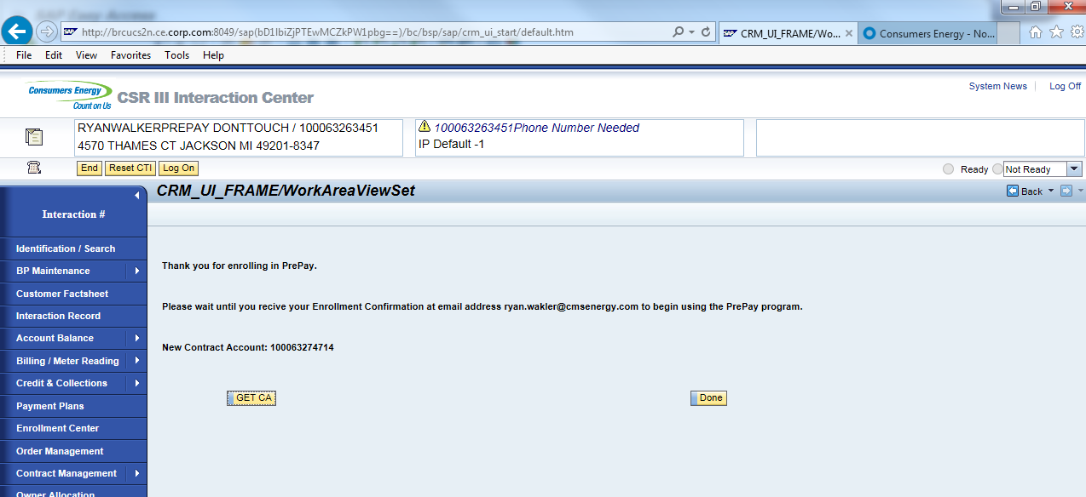
Clicking done on the summary screen will land on notification screen.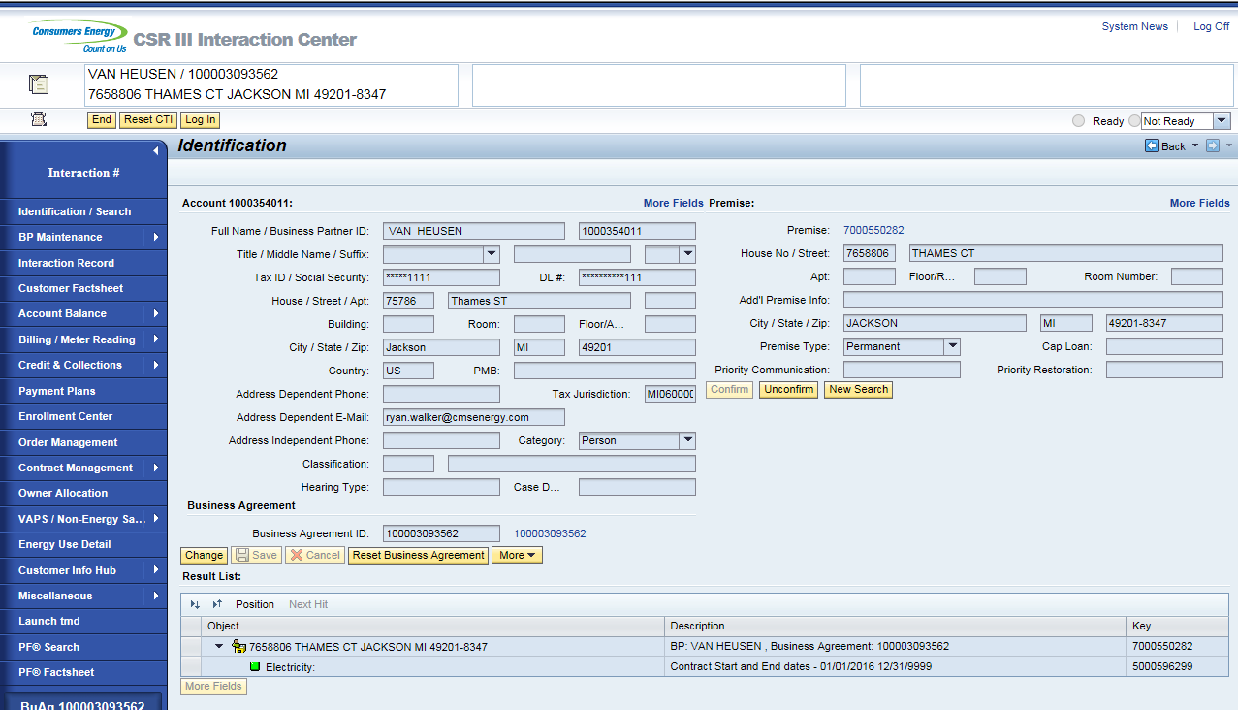
PrePay enrollment will process. If a meter read is not currently available on the account the enrollment will not trigger to PayGo system. Once the read is collected from the meter, the enrollment will process on PayGo side. This will also trigger the enrollment email to the customer notifying them that the enrollment is completed.

Enrollment Email:
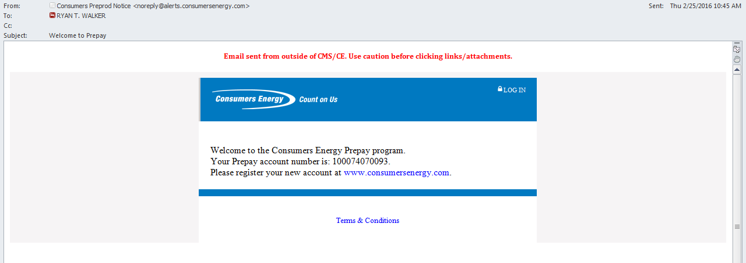

On enrollment, the Dunning procedure will update to CMS PrePay Customer Dunning procedure and Bill Consolidator will update to 0008 PrePay Account. This can be found by selecting the Business Agreement ID from the Identification / Search view and landing on the Business Agreement view.

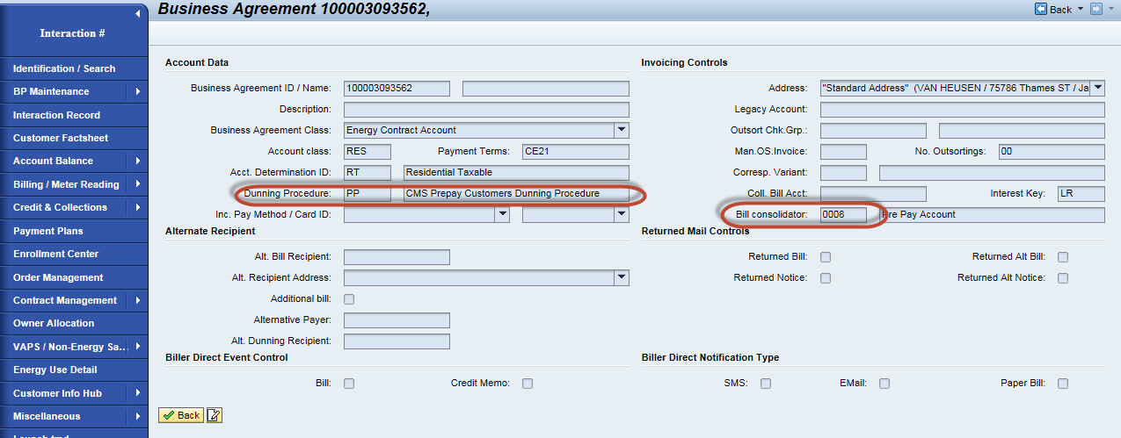
Confirming the account again in CRM and navigating to the enrollment center will show that the account is enrolled. 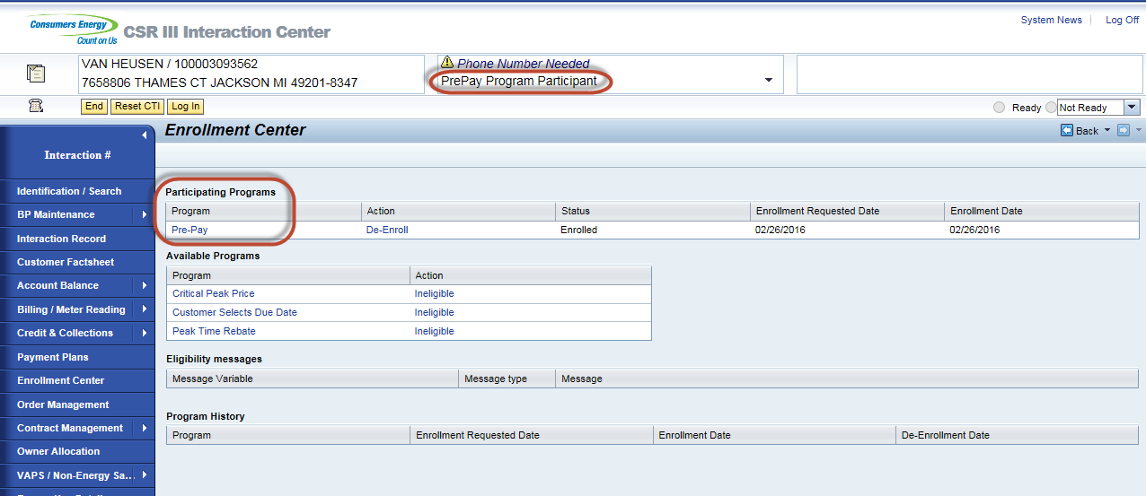

Interaction records are created. Selecting the Interaction Record from the navigation bar will display the interactions. Enrollment Pending interaction is created on enrollment. It is pending interaction because we are waiting to receive Confirmation back from PayGo.

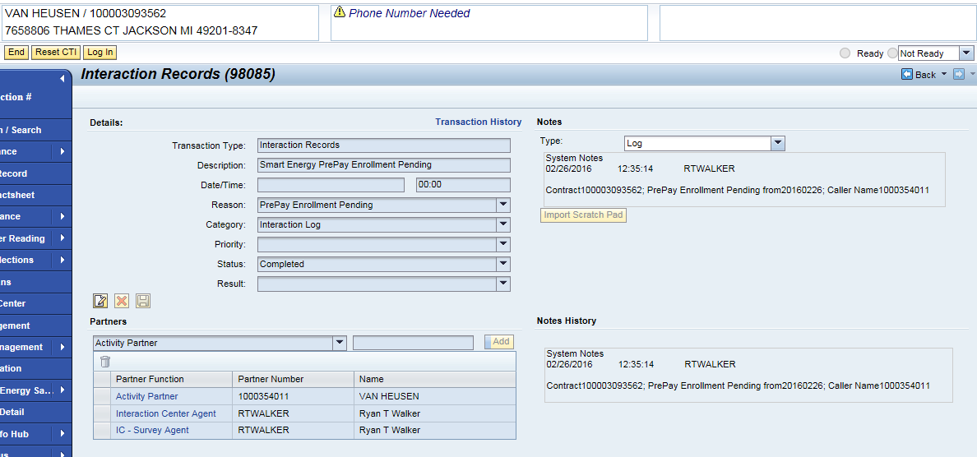
Enrollment Complete interaction is created when we receive confirmation back from PayGo. This update occurs on table ZTPPM_TXN_HIST.
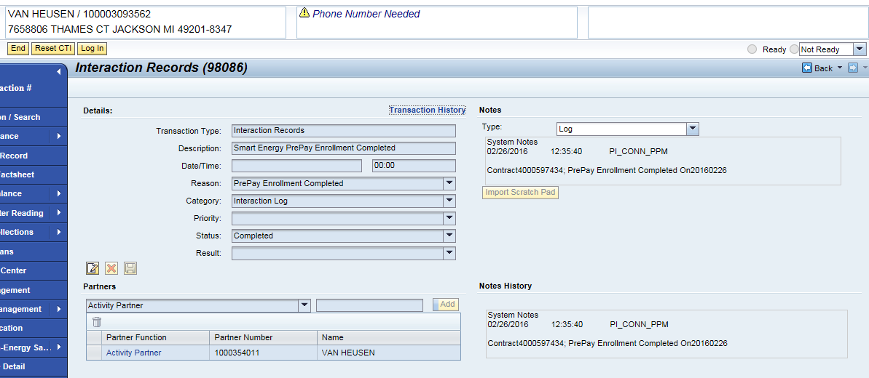
Enrollment Canceled interaction will be created when a de-enrollment occurs with a pending enrollment.

Process describes how CSR’s will access the PayGo site.

Confirm Business Agreement 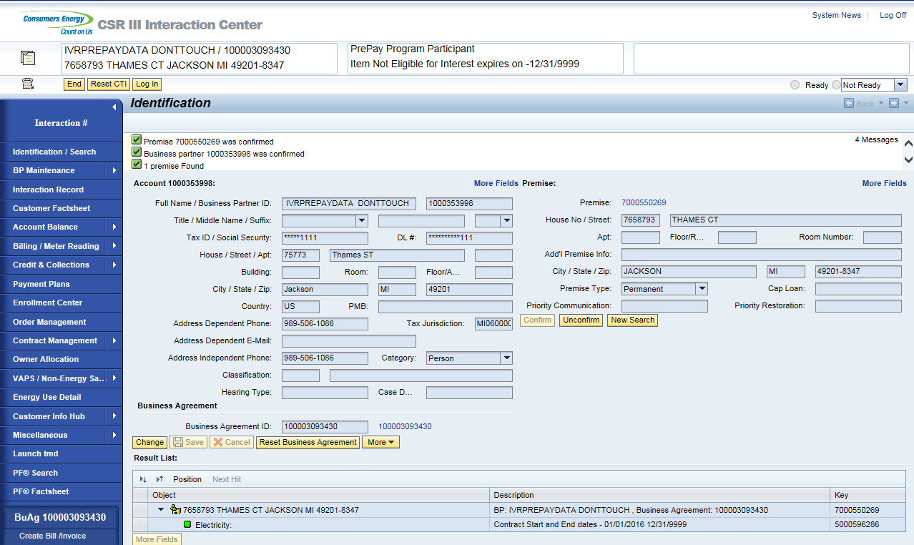

Click arrow next to Miscellaneous / Click on PrePay Portal
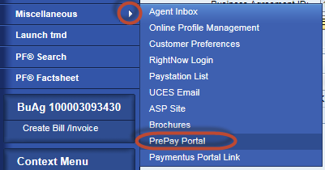
Land on PayGo site.
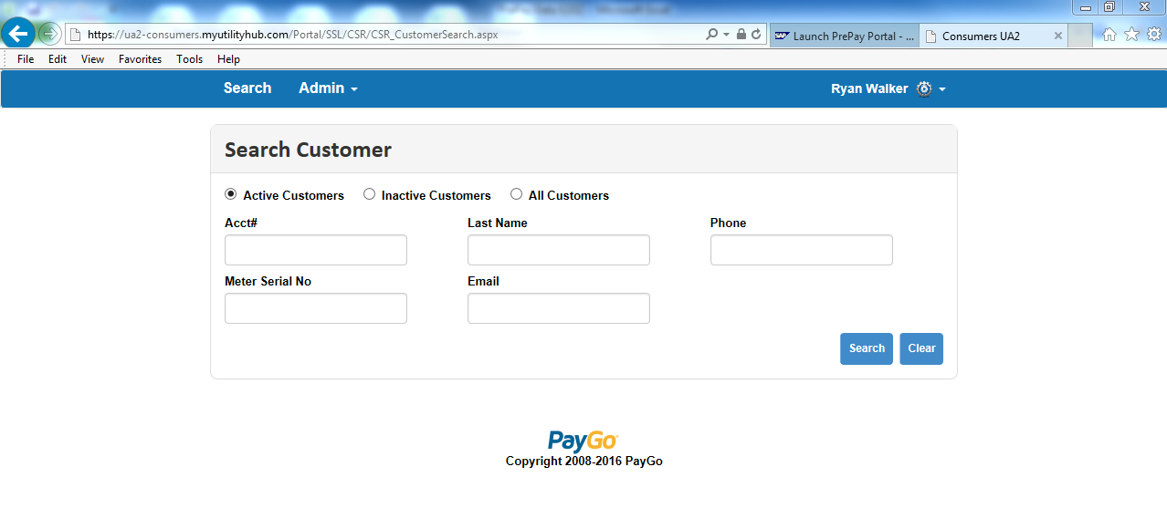

Search Business Agreement. Acct# is the Business Agreement/Contract Account number. Once search the CSR can click on the Acct# to display the account info.
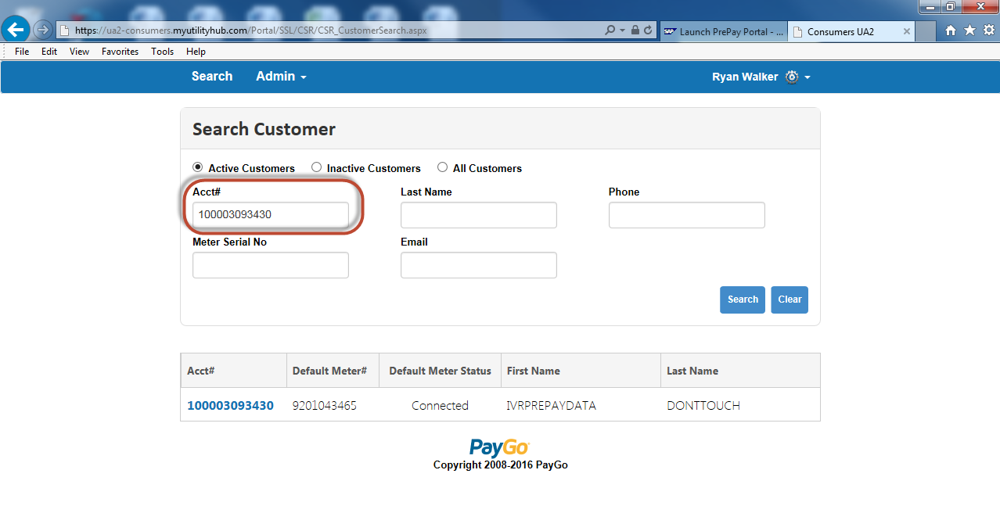
Account displays.
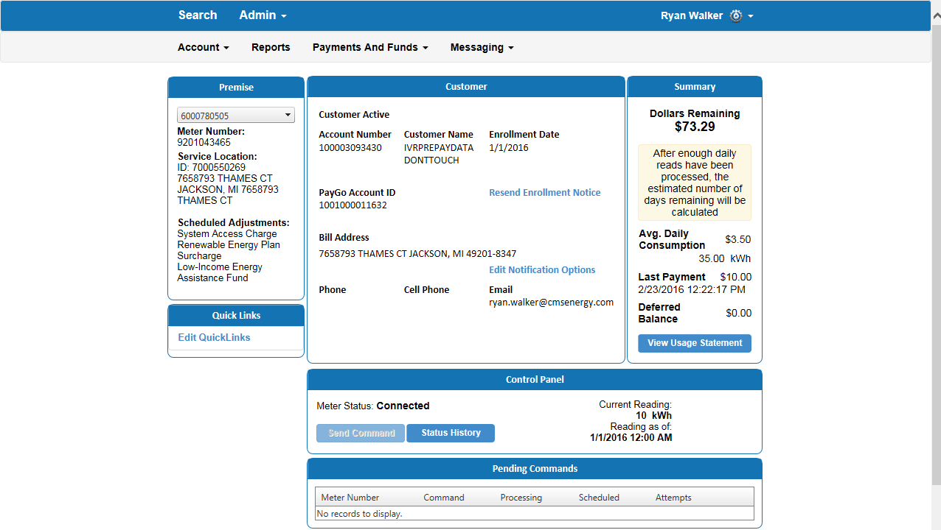

2.3 Customer Selects Due Date
This process shows how to perform a CSDD enrollment in CRM. Once the Enrollment has been initiated from the Enrollment Center, the process for CSDD Enrollment has not changed.

Business Agreement should be confirmed in CRM. This is done via an incoming call or by manually searching a Business Agreement.
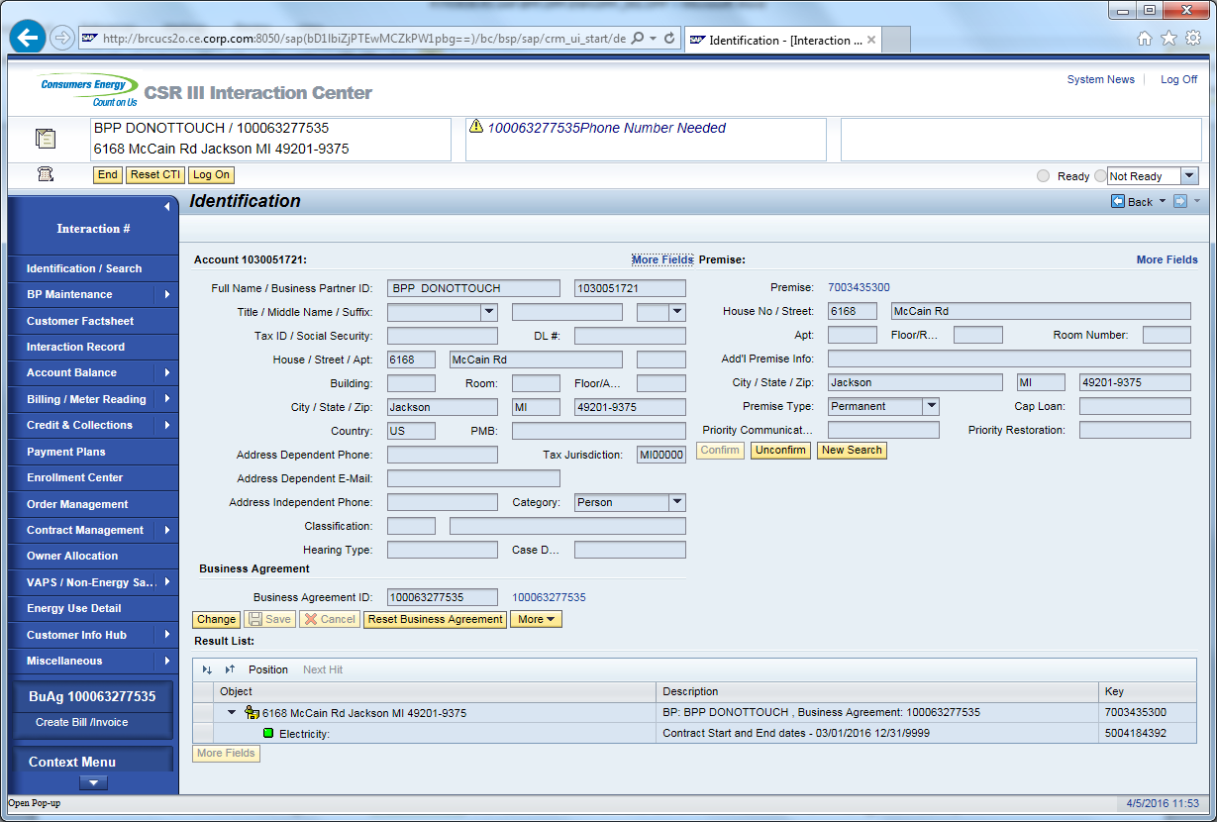

Once Business Agreement is confirmed, the CSR will click on the Enrollment Center from navigation bar.
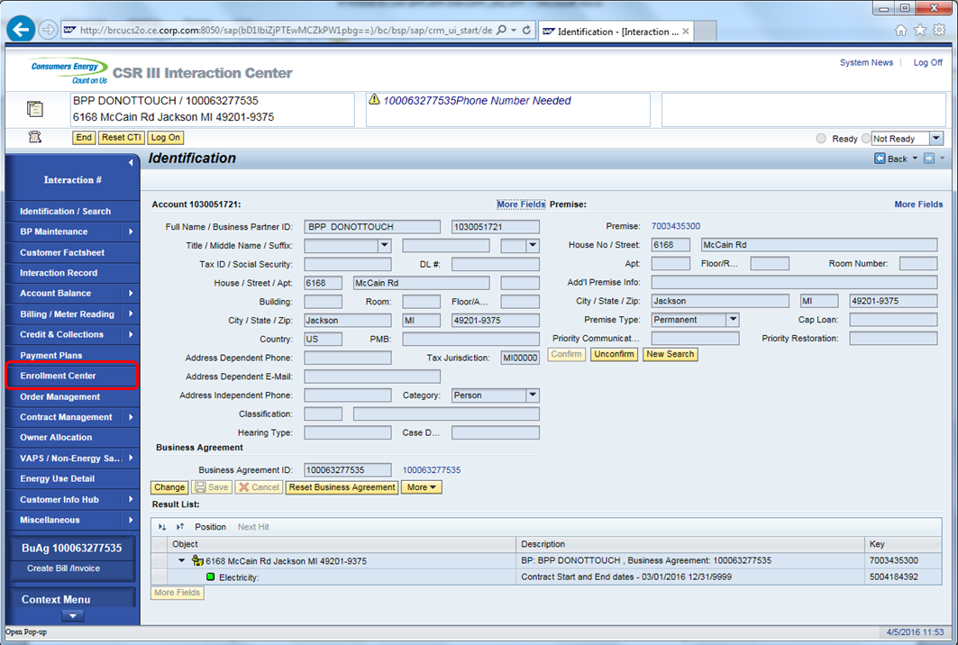

To enroll on CSDD; click ‘Enroll’ link next to CSDD under Available Programs.

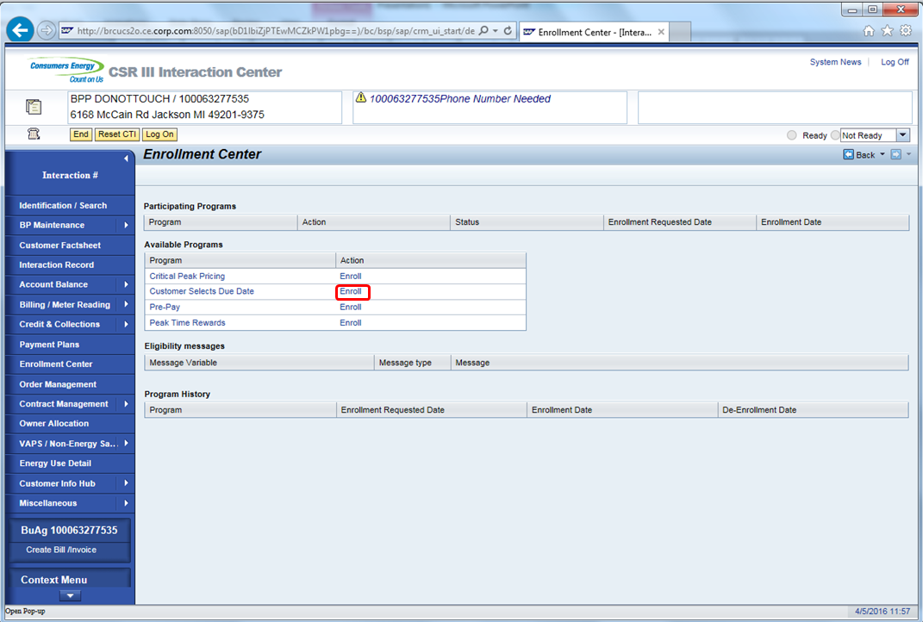

CSR will be taken to the Business Agreement Maintenance screen.

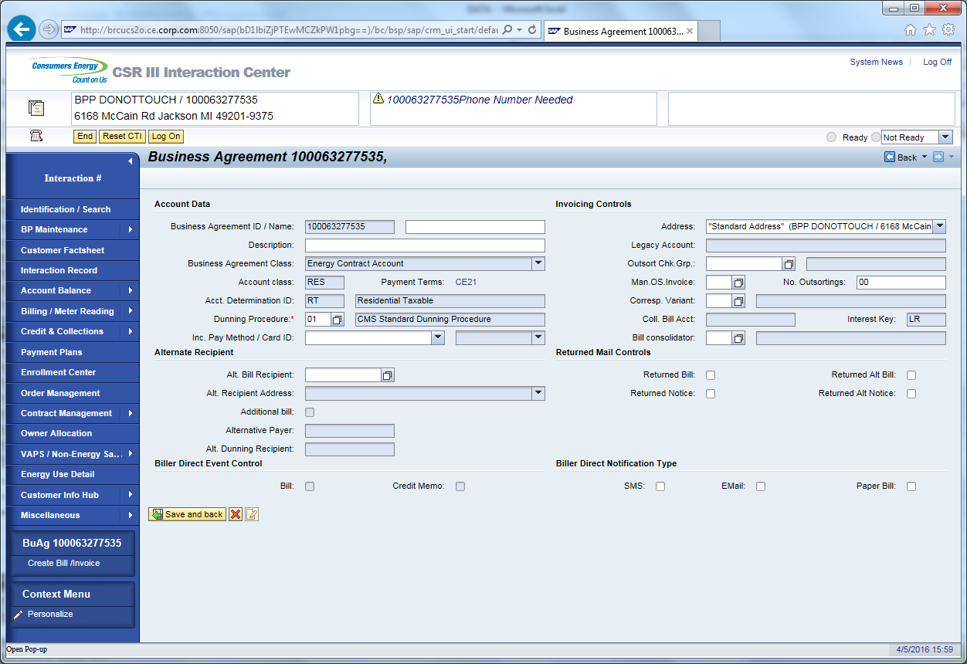

CSR will click on Payment Terms to change the Payment Terms for the Customer.
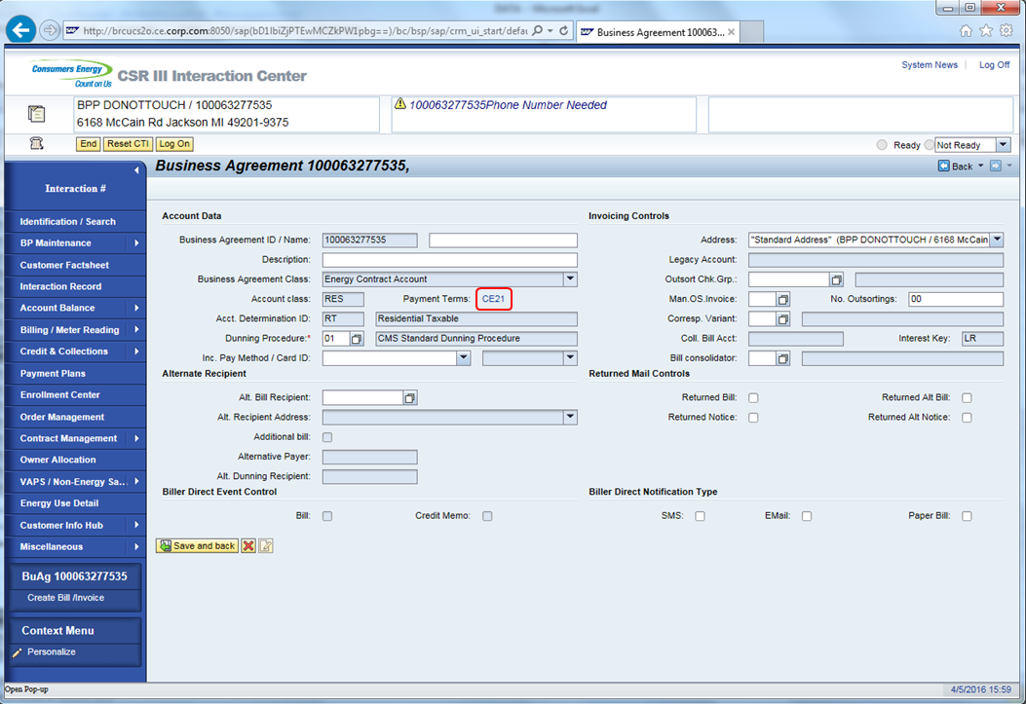

From the available Payment Terms; CSR will select the new Payment Term.

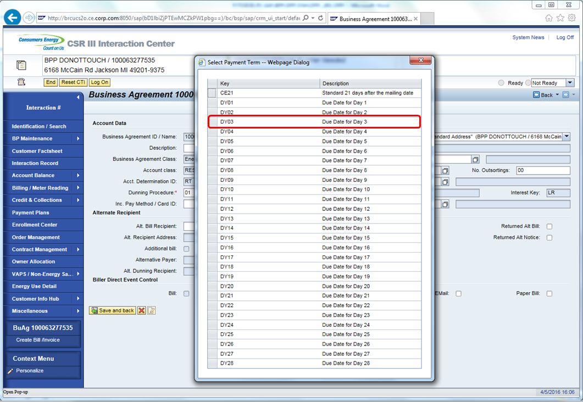

After selecting the New Payment Terms, a view to confirm or collect an email address from the customer is displayed. When finished, click the Complete Enrollment button.

Note: Email address is not required.
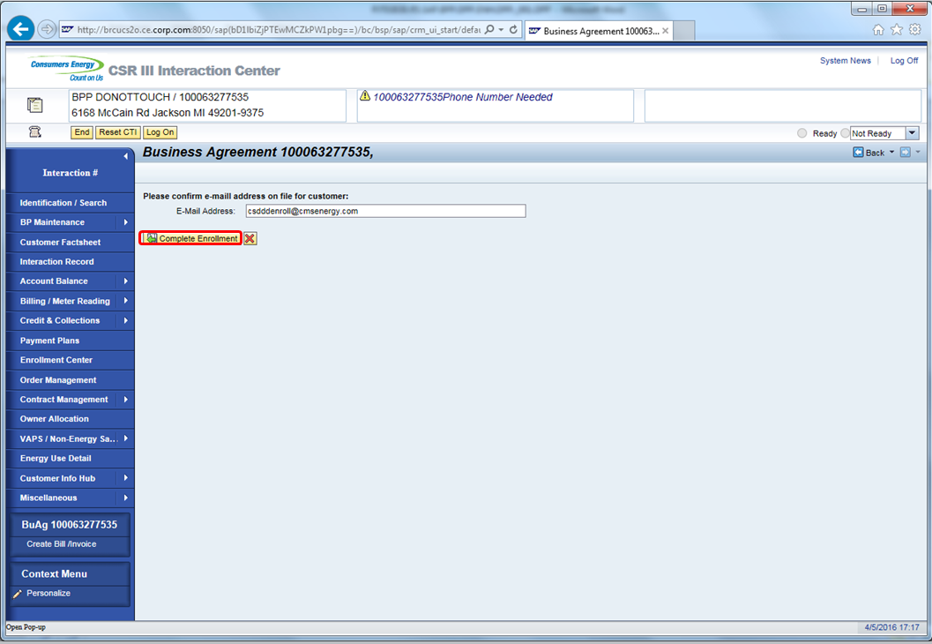

System will display a pop-up message to describe the disclaimer/summary to be read to customer on CSDD Effective Date.

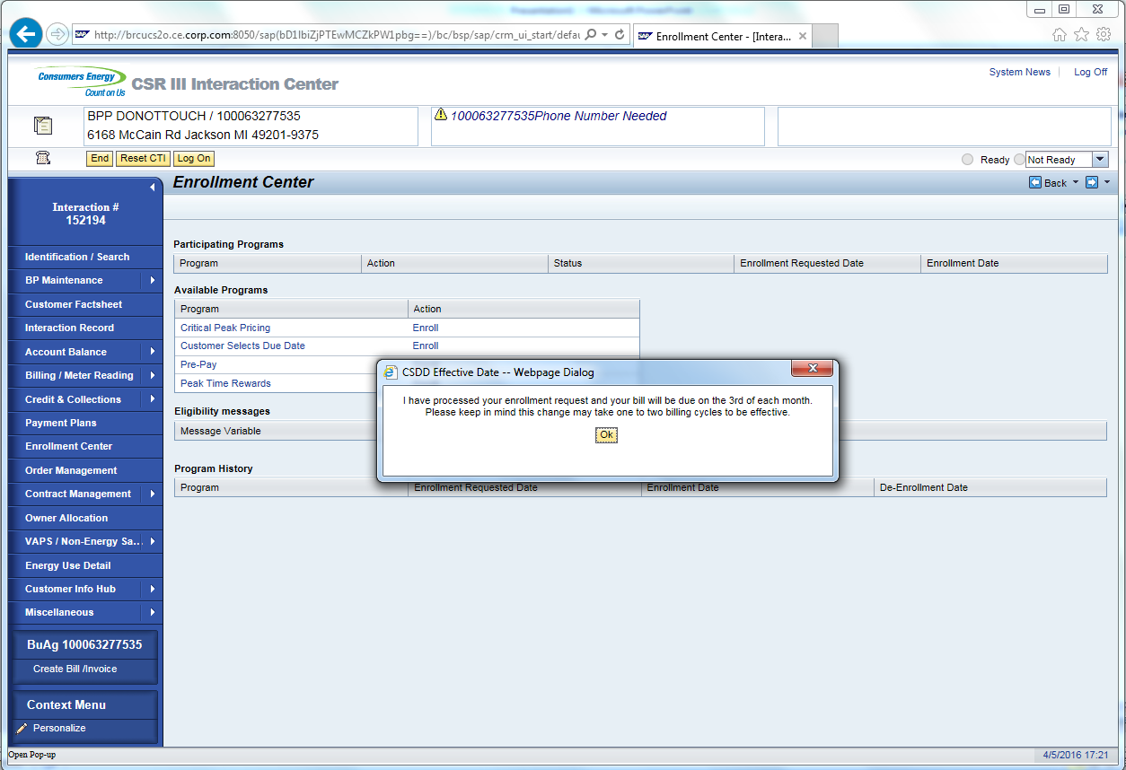

Confirming the account again in CRM and navigating to the enrollment center will show that the account is enrolled.

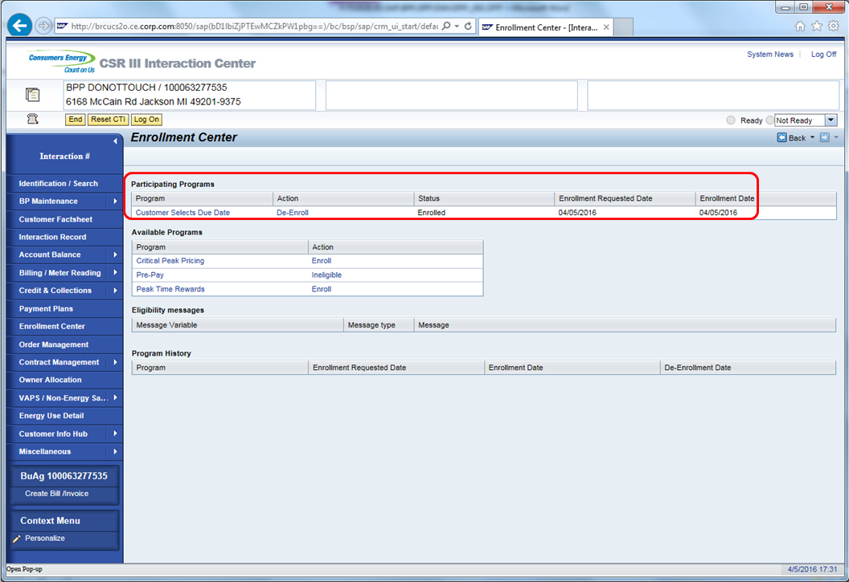

Interaction records is created. Selecting the Interaction Record from the navigation bar will display the interactions.

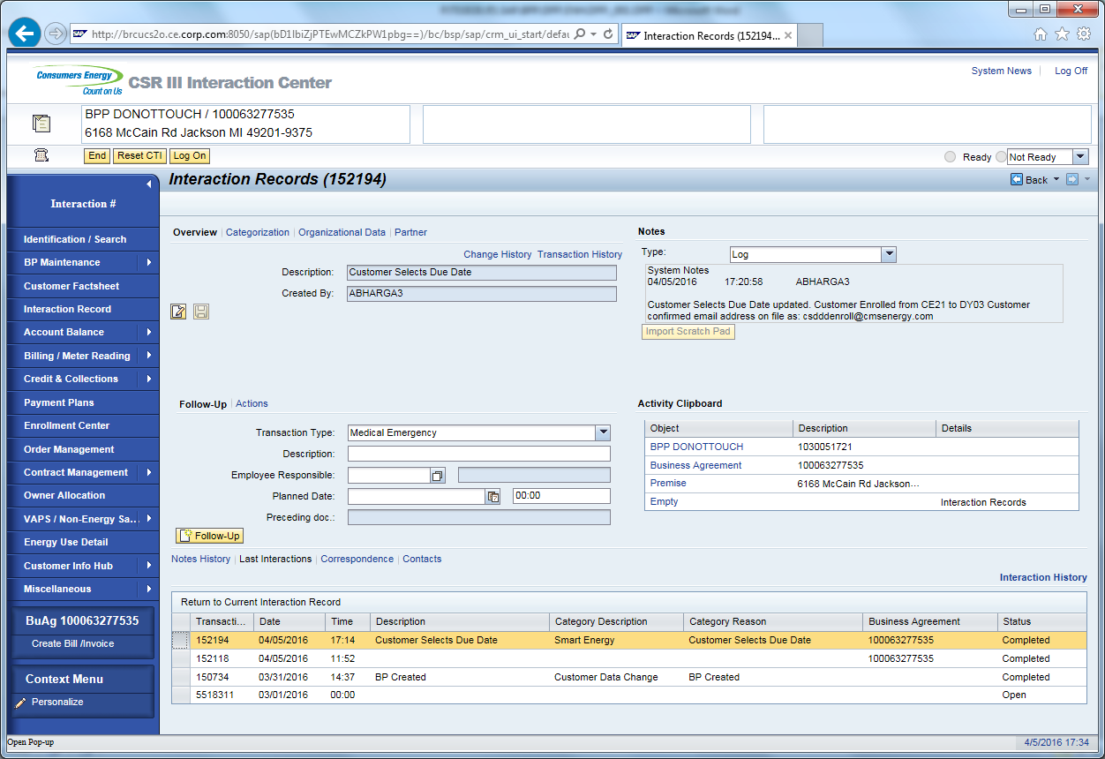

3.0 De-Enrollment

3.1 Critical Peak Pricing
This process shows how to perform a CPP De-enrollment in CRM.

Business Agreement should be confirmed in CRM via phone call or manual searching the Business Agreement.
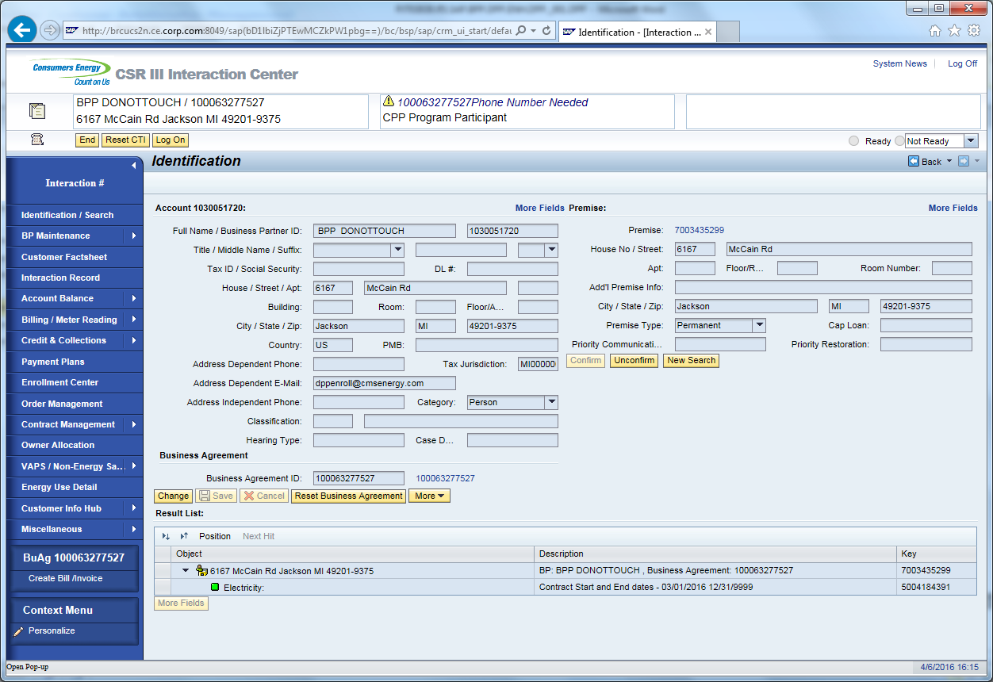

Navigate to Enrollment center.

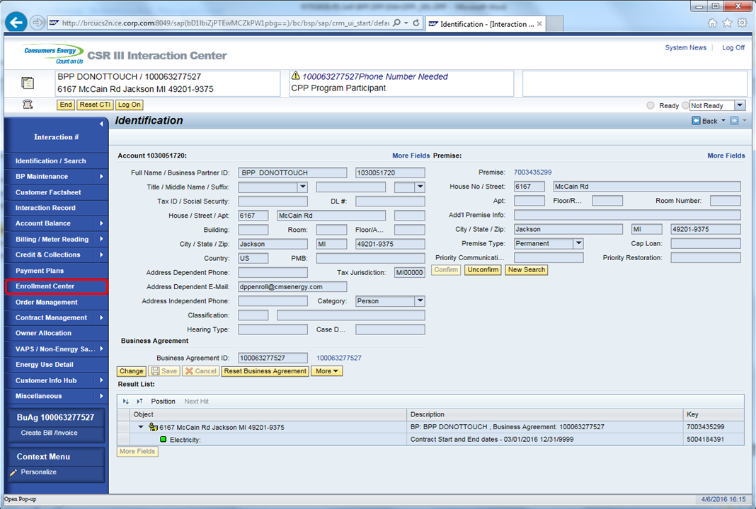

Click on De-Enroll button next to CPP under Participating Programs.

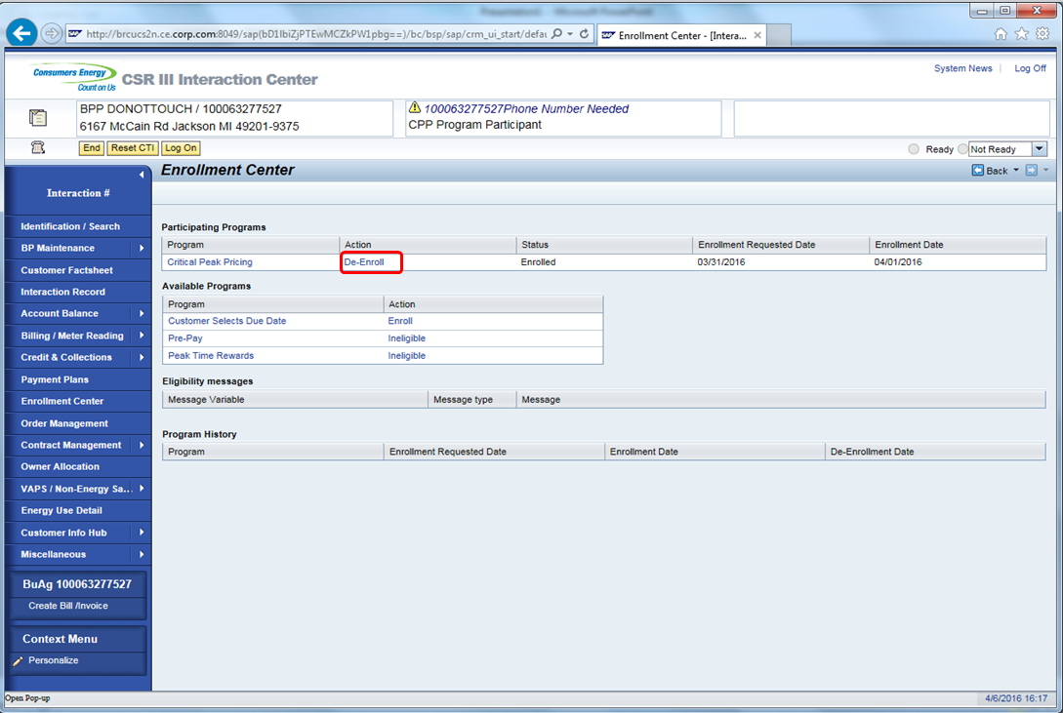

Pop-Up displays. CSR to confirm the de-enrollment from CPP.

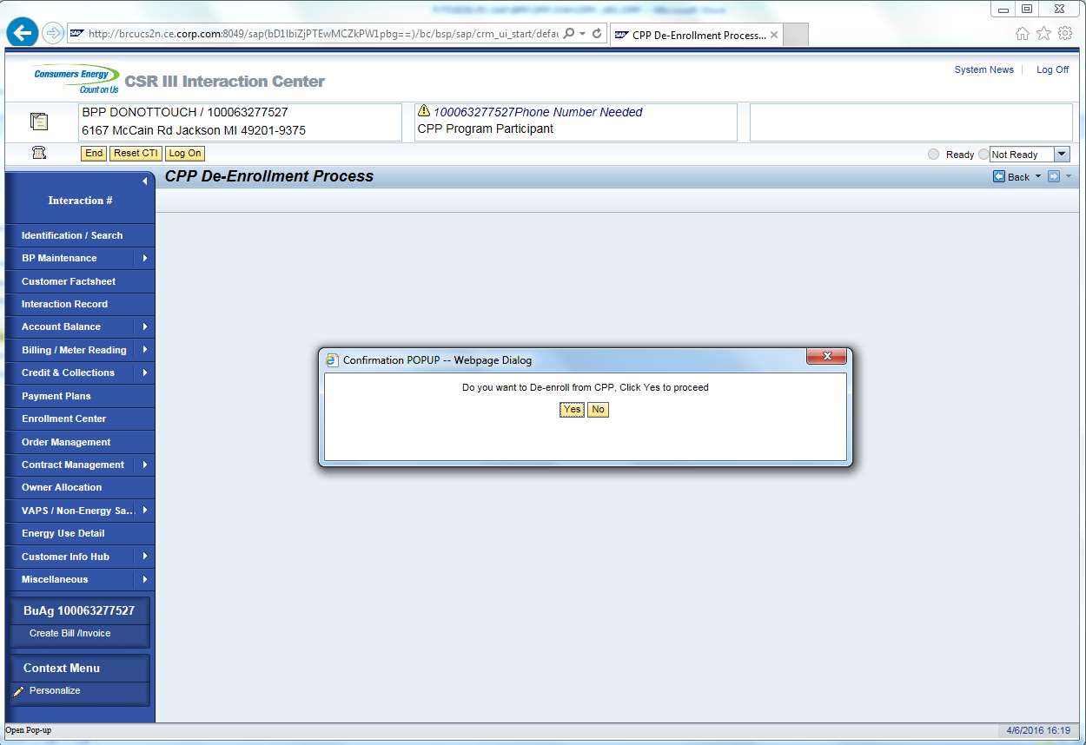

Click No or will cancel the De-Enrollment process and returns back to enrollment center. Clicking Yes will perform the de-enrollment and auto-navigate to the Identification/ search screen with a system message for successful de-enrollment.

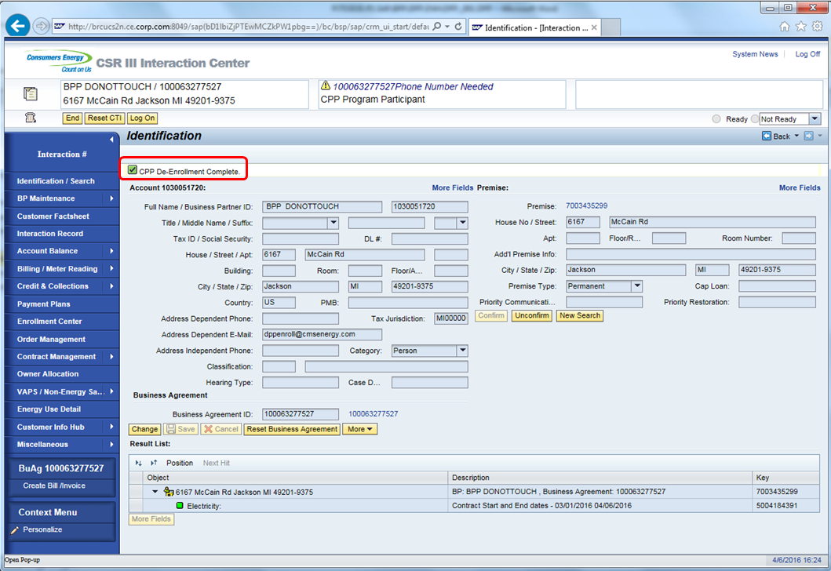

Confirming the account again in CRM and navigating to the enrollment center will show that the account is de-enrolled from CPP. CPP program enrollment is no logner displayed under Participating Programs. The Program history section will show the CPP Enrollment History.

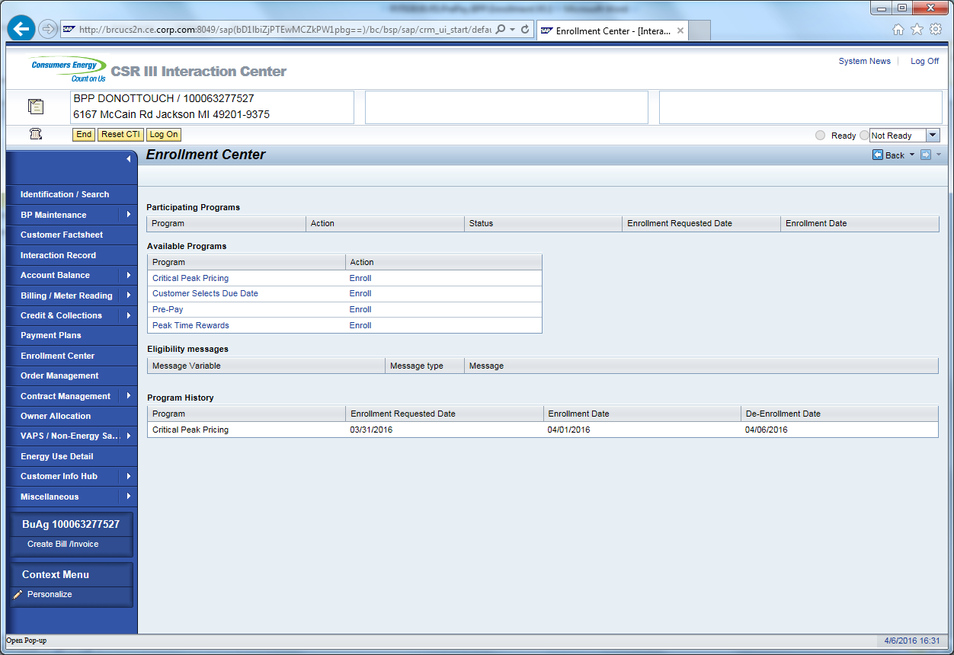

Interaction records is created on De-enrollment

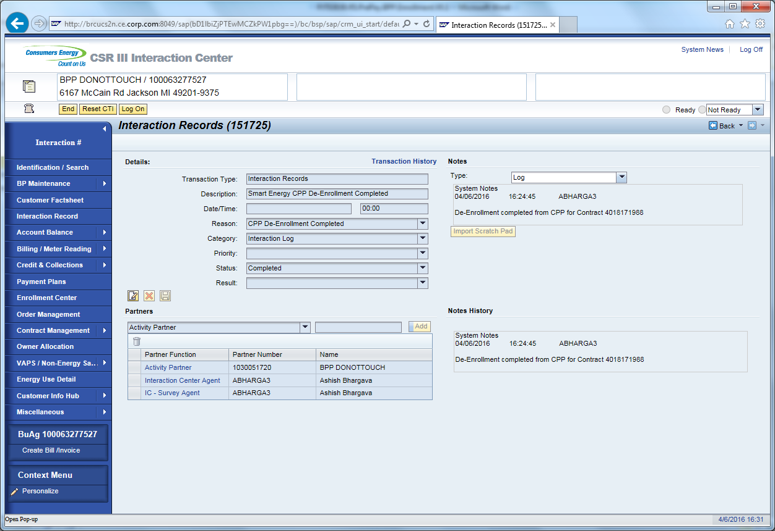

3.2 Pre-Pay De-Enrollment
This process shows how to perform a PrePay De-enrollment in CRM
Business Agree confirmed in CRM via phone call or manual searching the Business Agreement. 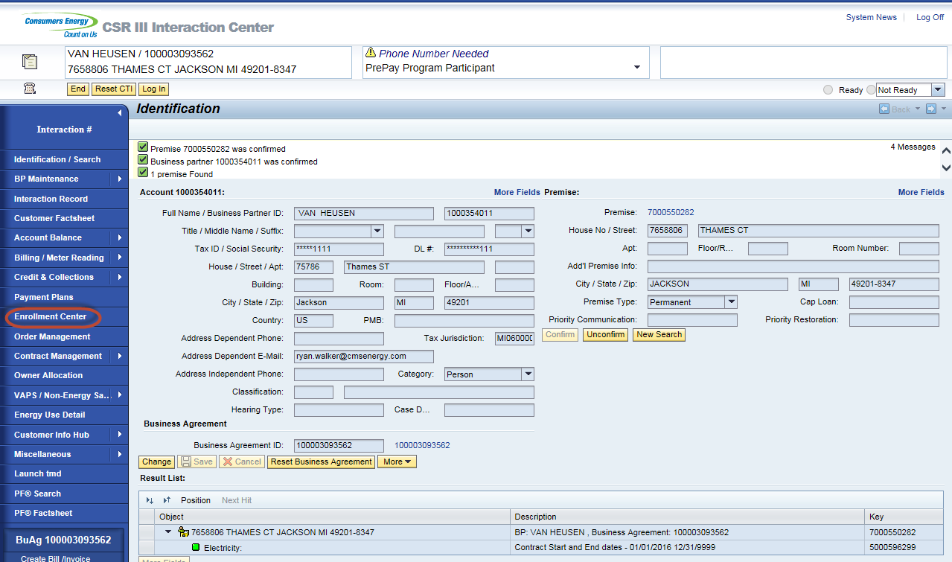

Enrollment Center displays / Click on ‘De-Enroll’
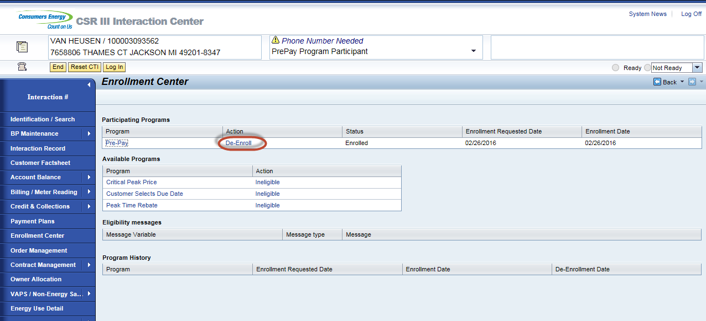
Pop-Up displays. CSR will tell the customer what their current balance will be on post pay. Business role states that if the customer wants to participate in SPP or WPP they will not be able to for 1 year. 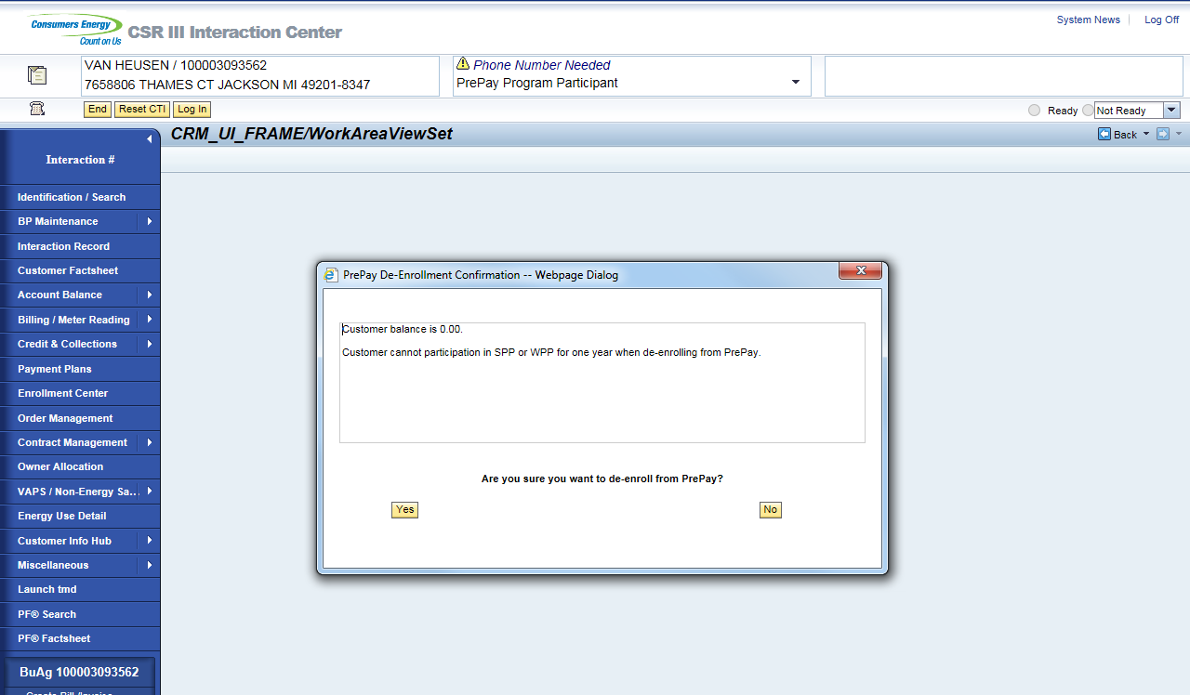
Click No or will returns back to enrollment center.
Click yes lands on Identification/ search.
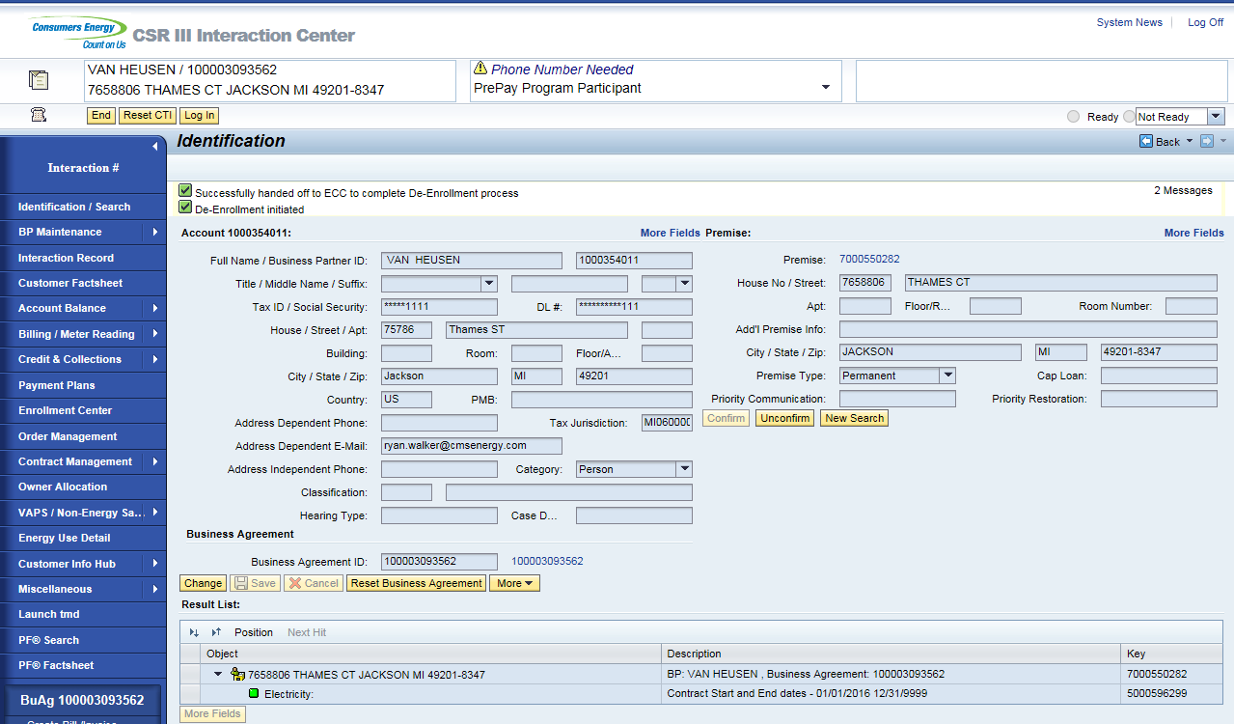

From the search screen, the CSR can select the business agreement ID number, which will land them on the Business Agreement view. The Bill consolidator ‘0008’ PrePay Account will be removed and the Dunning Procedure will be updated to CMS Standard Dunning Procedure.
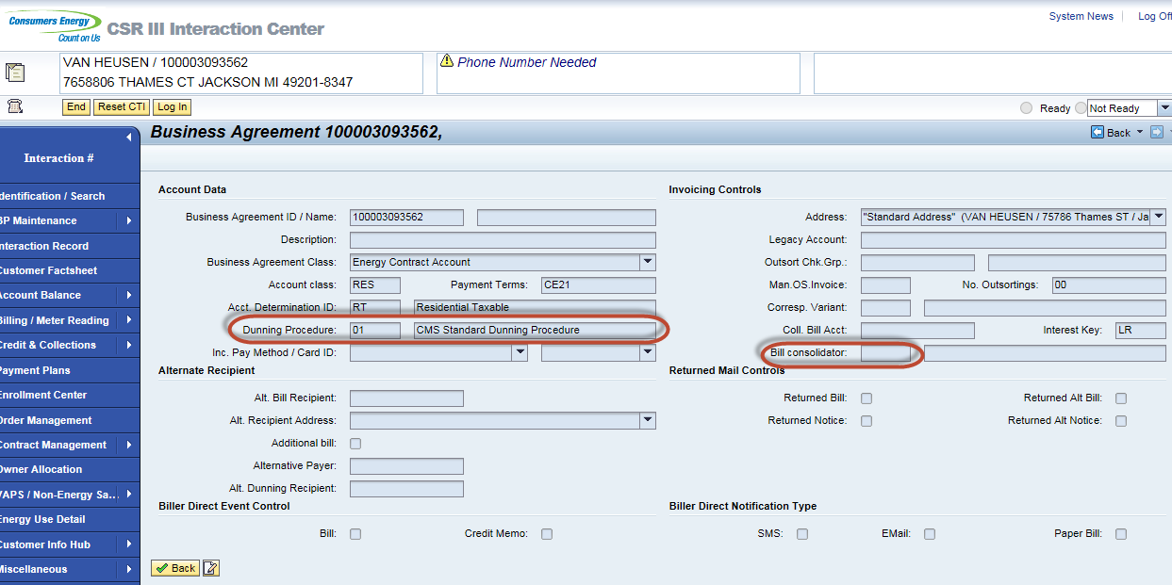

Interaction records will be created on De-Enrollment. De-Enrollment pending interaction record is created on PrePay de-enrollment. It shows a pending status which is waiting for the success message to come back from PayGo.
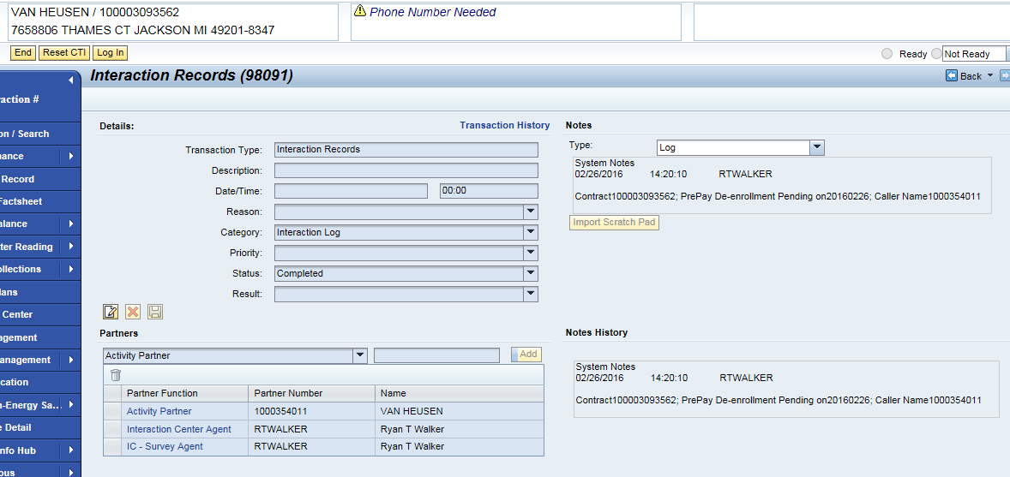
De-enrollment completed interaction record is create when SAP receives a success message from PayGo. 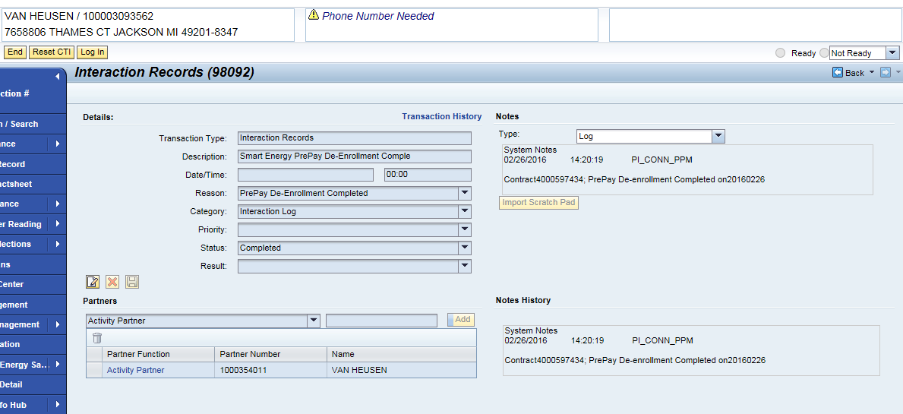

CSDD De-Enrollment
This process describes the de-enrollment process for CSDD. The De-Enrollment process for CSDD has not changed other than initiating it from the Enrollment Center.

Business Agreement should be confirmed in CRM. This is done via an incoming call or by manually searching a Business Agreement.
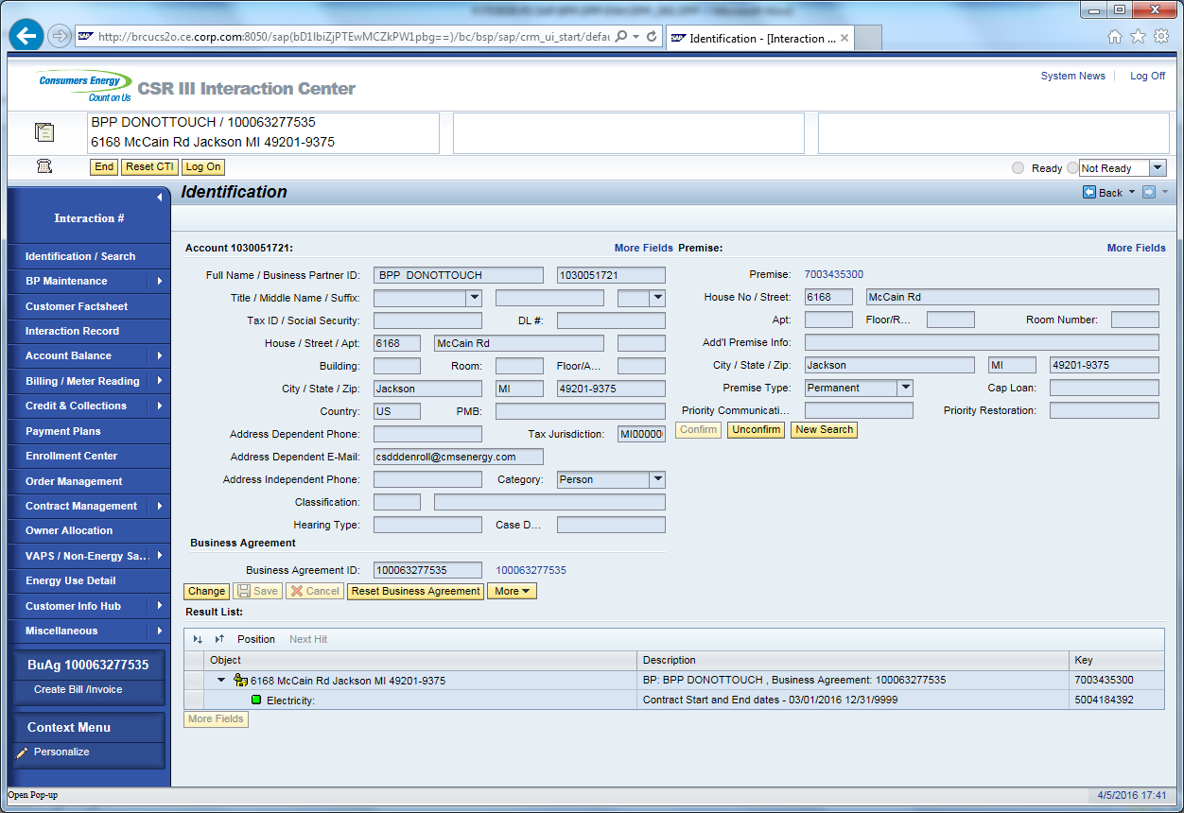

Once Business Agreement is confirmed, the CSR will click on the Enrollment Center from navigation bar.



To De-enroll on CSDD; click “De-Enroll” link next to CSDD under Participating Programs.

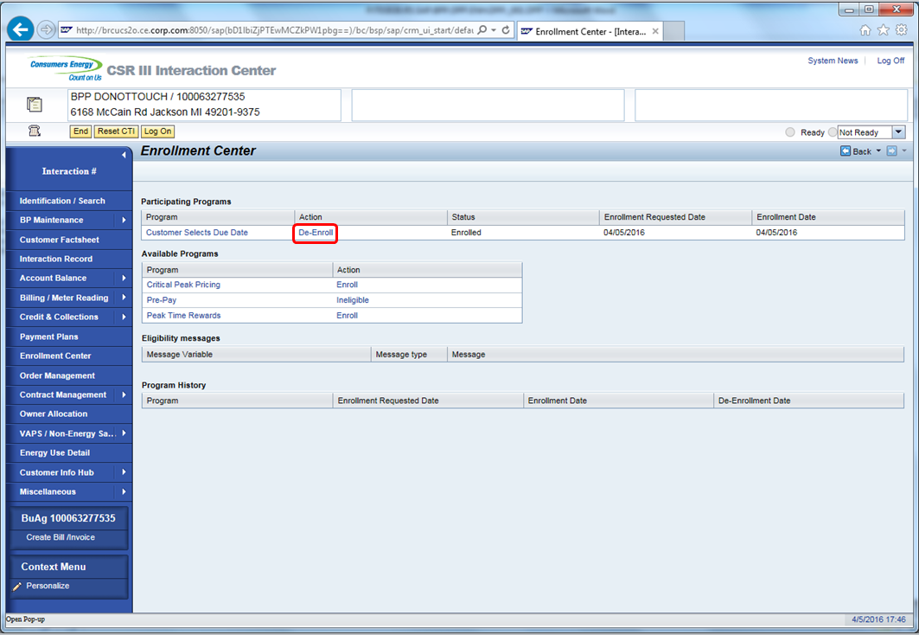

CSR will be taken to Business Agreement Maintenance Screen.

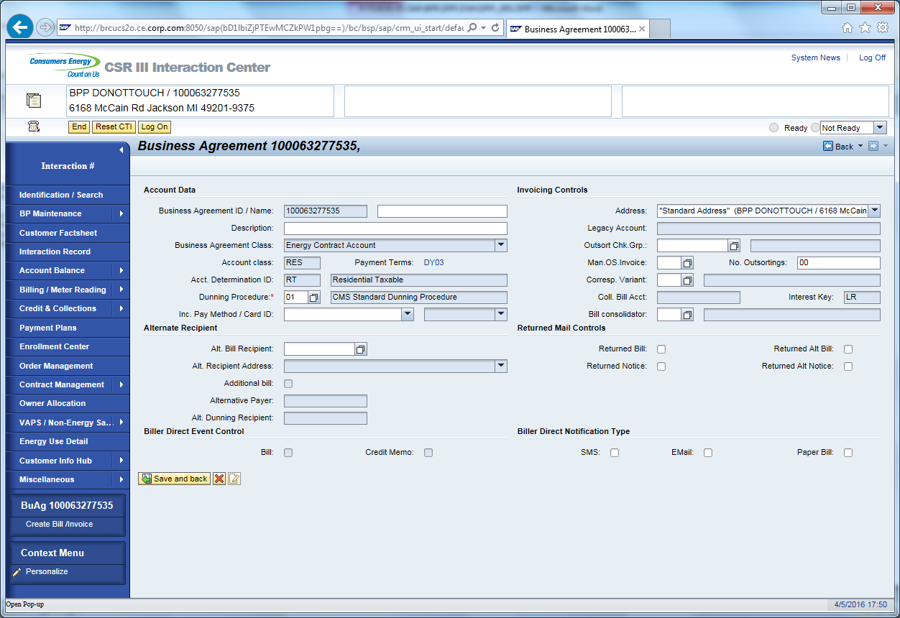

CSR will click on Payment Terms Link and select the Payment Term CE21

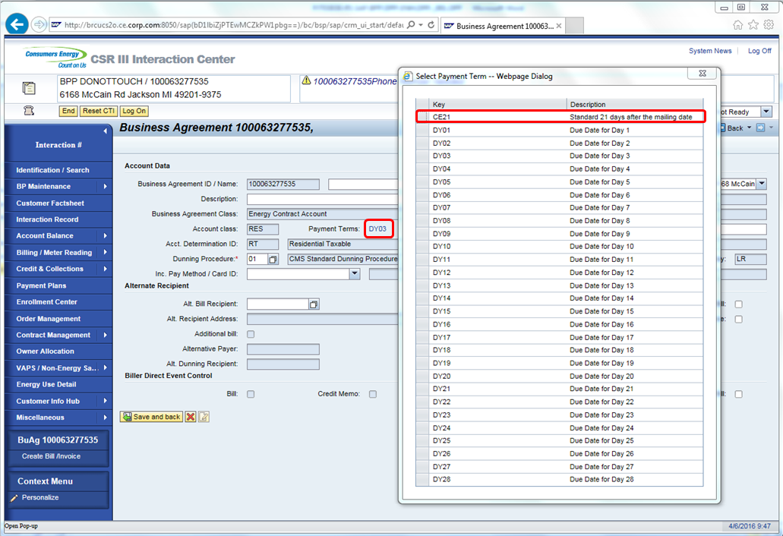

A view to confirm or collect the customers email address is displayed (however email is not required to complete processing). Once completed, Click the Complete Enrollment button.

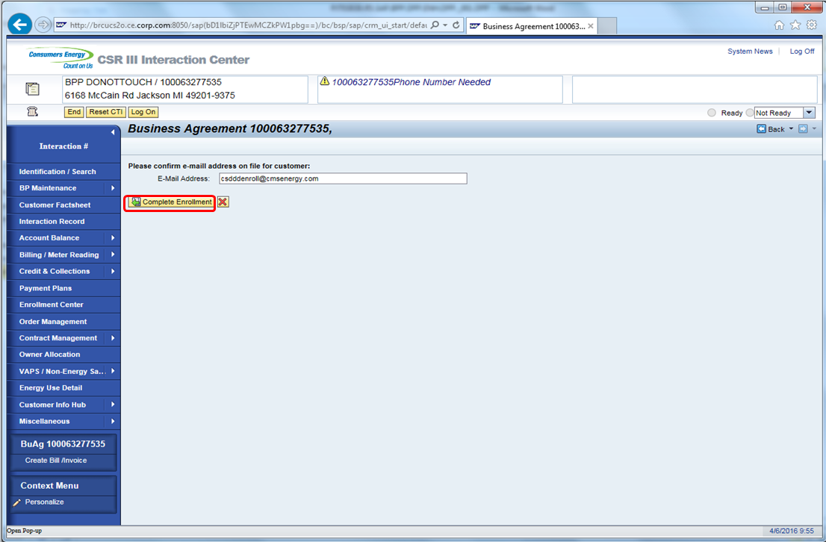

Confirm the Business Agreement again.

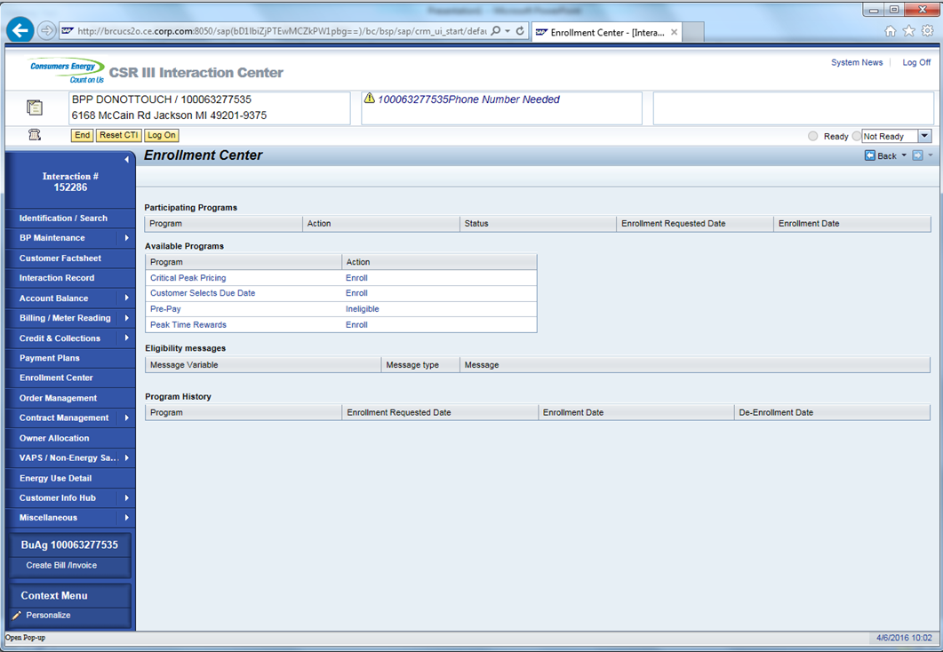

Navigate to Enrollment Center and CSDD will not be shown under Participating Program section.



De-enrollment completed interaction record is created.

